**A**

**Project Report on**

**PORTFOLIO USING CHATBOT**

Submitted in partial fulfilment of completion of the course

**Advanced Diploma in IT, Networking and Cloud Computing**

Submitted by:

**Sadhana Prajapati**

**(Edunet Mentor) Miss Deepika Singh**



**Year 2023-2024**

Ministry of Skill Development & Entrepreneurship

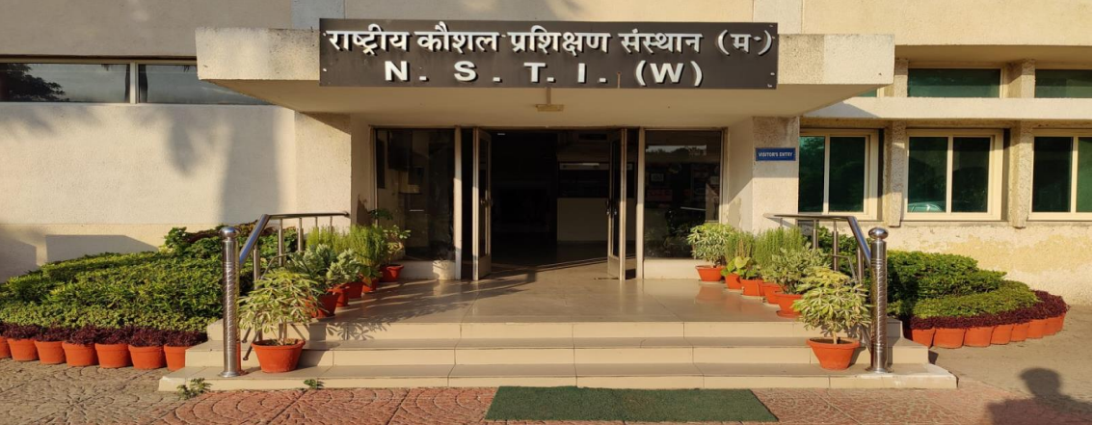

**NSTI(W) NOIDA**

**ABSTRACT**

This project showcases a dynamic portfolio, crafted with HTML, CSS, and JavaScript, to spotlight individual skills and achievements. It features a user-friendly interface designed for seamless exploration across devices. The addition of an AI-powered chatbot, leveraging IBM Watson, enhances interactivity, allowing users to inquire about the creator, projects, or engage in casual conversations. The fusion of modern web development techniques and AI integration creates a personalized and innovative user experience. The report details technical aspects, including IBM Watson services integration, web development principles, and user feedback, reflecting a successful blend of creativity and technology for engaging web interactions.

**ACKNOWLEDGEMENT**

We extend our heartfelt gratitude to our guide, **Miss. Deepika Singh**, for her invaluable assistance, guidance, and cooperation in the successful completion of this project. Special appreciation goes to our course coordinator, **Mr. D.A. Guruvulu**, for his insightful suggestions and guidance. We are thankful to our respected Head of the division, **Smt. Shashi Mathur [JD NSTI(W) NOIDA],** for granting us access to essential facilities and resources crucial for our project's success. Finally, we express deep appreciation to our friends and family for their unwavering support and encouragement. Their presence has been a constant source of strength and motivation throughout our project.

**ADVANCE DIPLOMA IN IT NETWORKING** & **CLOUD COMPUTING**

The Advanced Diploma in IT Networking and Cloud Computing program offered by **NSTI (W) Noida** in collaboration with **Edunet Foundation** is a comprehensive course designed to equip students with advanced skills in information technology and cloud computing. This program covers a wide range of topics, including Computer Networking, Database Management, Virtualization, Cloud Technologies, and Cybersecurity. Students will gain hands-on experience through practical labs, workshops, and real-world projects, enabling them to excel in the rapidly evolving IT industry. Upon completion of the program, Graduates will have a strong foundation in both IT Fundamentals and Cloud Computing, making them highly sought-after professionals in the field.

**TABLE OF CONTENTS**

|  |  |  |
| --- | --- | --- |
| **SNO** | **TOPIC** | **Page No** |
| **1.** | INTRODUCTION TO PROBLEM | 04 |
| **2.** | REQUIREMENTS SPECIFICATION | 04-05 |
| **3.** | OVERVIEW | 06 |
| **4.** | PROJECT MODULE | 06 |
| **5.** | SAMPLE SCREENSHOTS | 07-10 |
| **6.** | CHATBOT CREATION & INTEGRATION | 10-21 |
| **7.** | HOSTING PORTFOLIO ON IBM CLOUD | 21-31 |
| **8.** | SOURCE CODE | 32-77 |
| **9.** | FUTURE SCOPE | 77 |
| **10.** | CONCLUSION | 78 |
| **11.** | REFERENCES | 78 |

1. **INTRODUCTION TO PROBLEM**

In today's digital landscape, individuals encounter the challenge of effectively showcasing their professional accomplishments while engaging their audience in a dynamic and personalized manner. Traditional portfolios often fall short in providing interactivity, struggling to deliver an immersive experience for visitors. Additionally, the absence of efficient and engaging communication channels on personal websites remains a prevalent issue.

This project endeavors to tackle these challenges by crafting a dynamic and interactive portfolio. Beyond showcasing the creator's skills and achievements, it introduces a unique user experience through an AI-powered chatbot. The absence of personalized and intelligent communication tools on personal websites poses a limitation in conveying information and engaging with the audience effectively. The integration of IBM Watson's capabilities into the chatbot aims to bridge this gap, offering natural language interactions that elevate user engagement, resulting in a more memorable and personalized experience.

At its core, the project's problem statement revolves around the necessity for a modern, interactive, and intelligent platform. This platform seamlessly integrates web development principles with artificial intelligence, creating a compelling and personalized user experience. Through this initiative, we aspire to redefine the way individuals present their professional profiles online, providing a solution that not only meets current expectations but also sets a standard for future personal websites.

1. **REQUIREMENTS**

**2.1 Technology Stack**

**Front-End:**

**HTML** **(Hypertext Markup Language):** Used for structuring the content and layout of web pages.

**CSS (Cascading Style Sheets):** Employed for styling and formatting the website, defining its visual appearance.

**JavaScript:** Utilized for adding interactivity and dynamic behavior to the frontend of the website.

**Front-End Framework:**

**Bootstrap:** A front-end framework for designing responsive and visually appealing user interfaces.

**2.2 Hardware**

Laptop/ Computer

**2.3 Software**

Operating System (OS)

Version Control System

Text Editors and Integrated Development Environments.

**2.4 Deployment Environment**

**GitHub**

**3. OVERVIEW**

The showcased portfolio in this project is a dynamic and immersive platform meticulously crafted to narrate the professional journey, skills, and achievements of individuals in a captivating manner. Utilizing a modern and responsive web design, the portfolio serves as a visual narrative, providing a seamless experience for visitors across various devices.

**4. PROJECT MODULE**

The entire project revolves around a single module, the **User Module**, which encompasses the following sections:

* Home
* About
* Skills
* Education
* Projects
* Certification
* Contact

**Home:** Welcome to My Portfolio. This section serves as the user interface, providing an introduction to my journey.

**About:** Learn more about me – my background, interests, and what drives my passion for web development.

**Skills:** Discover the skills I've acquired in various technologies and tools, essential for full-stack web development.

**Education**: Explore my academic journey, highlighting key milestones and achievements.

**Projects:** View a showcase of my latest projects, demonstrating my creativity and technical expertise.

**Certification:** Check out my certifications, showcasing my commitment to continuous learning and skill enhancement.

**Contact:** Feel free to connect with me for further information, collaboration, or any inquiries.

**5. SAMPLE SCREENSHOTS**

**Home Page**

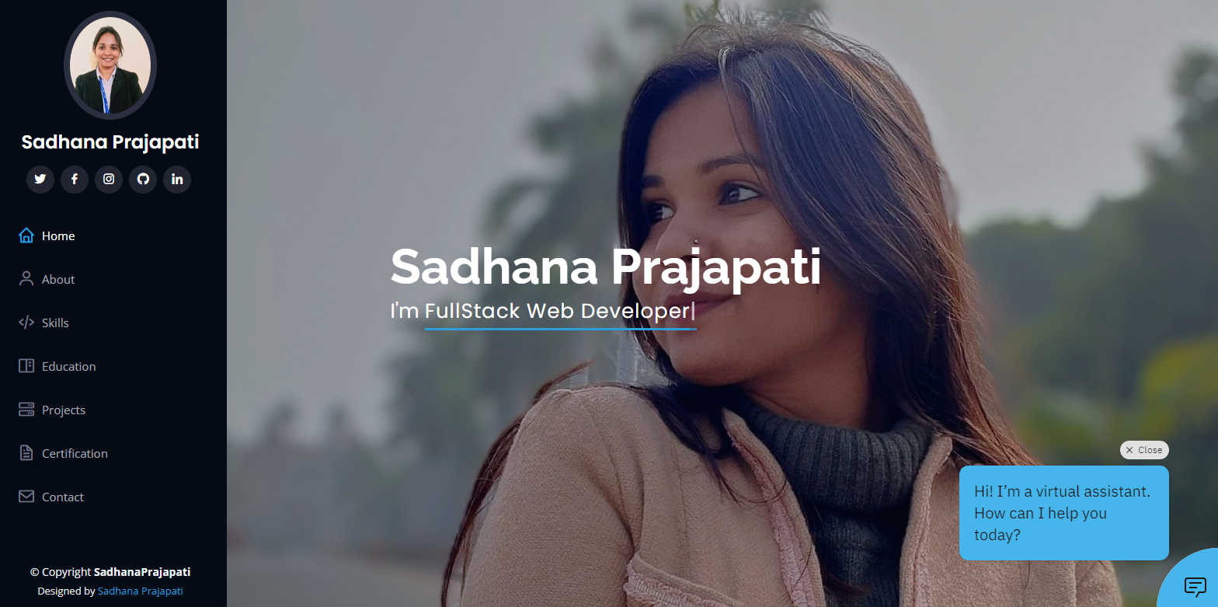

**About Page**

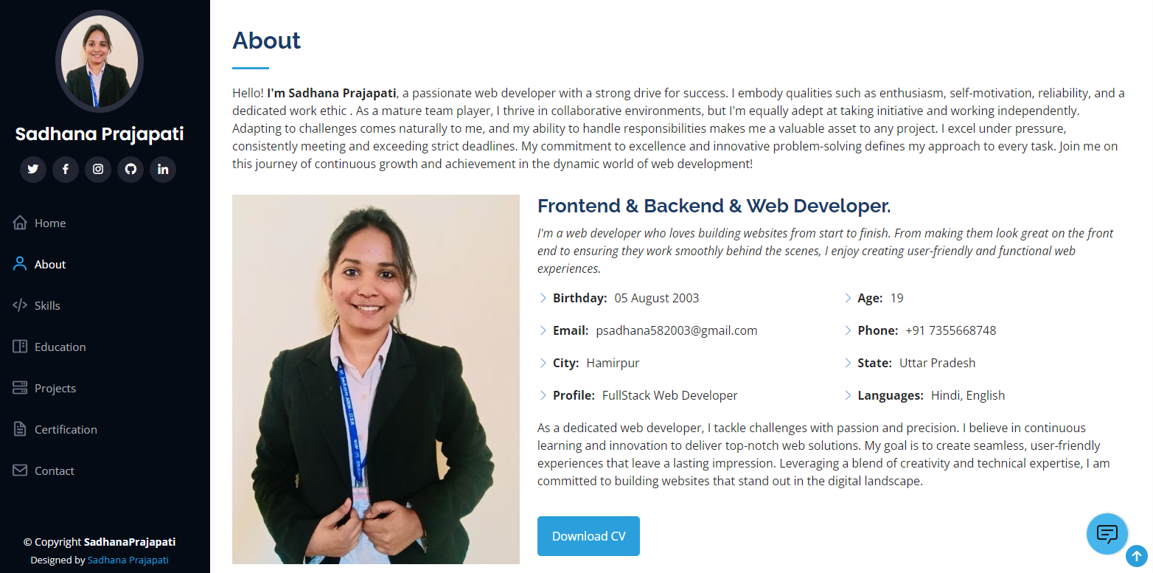

**Skills Page**

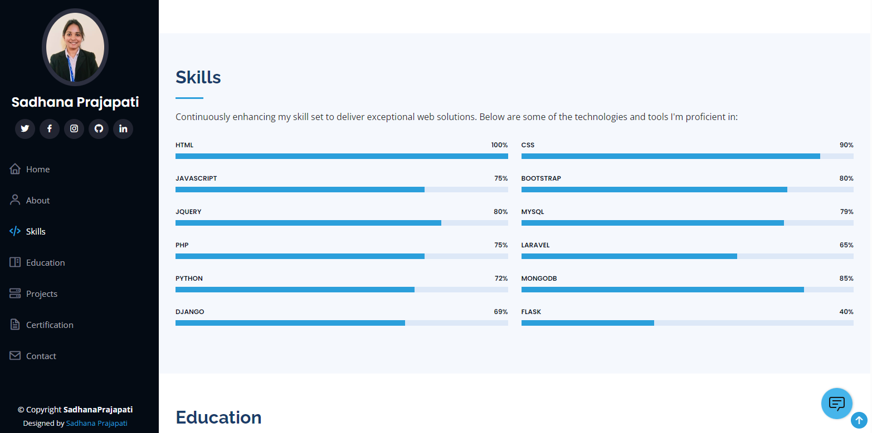

**Education Page**

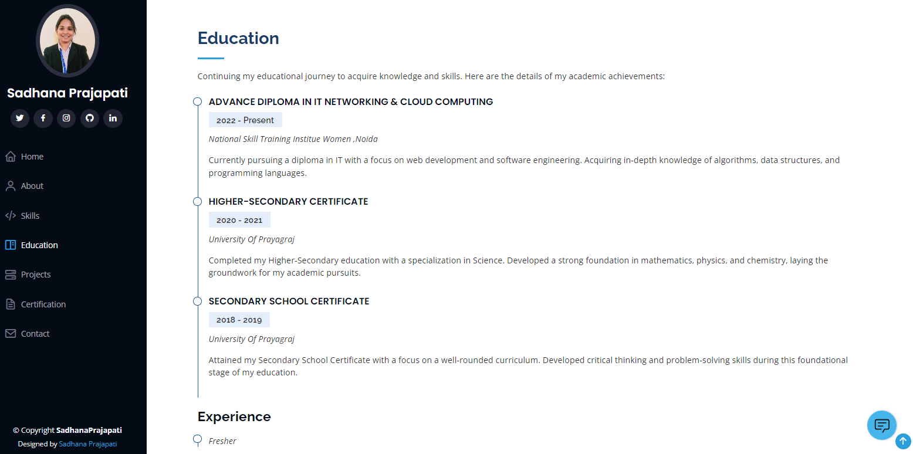

**Projects Page**

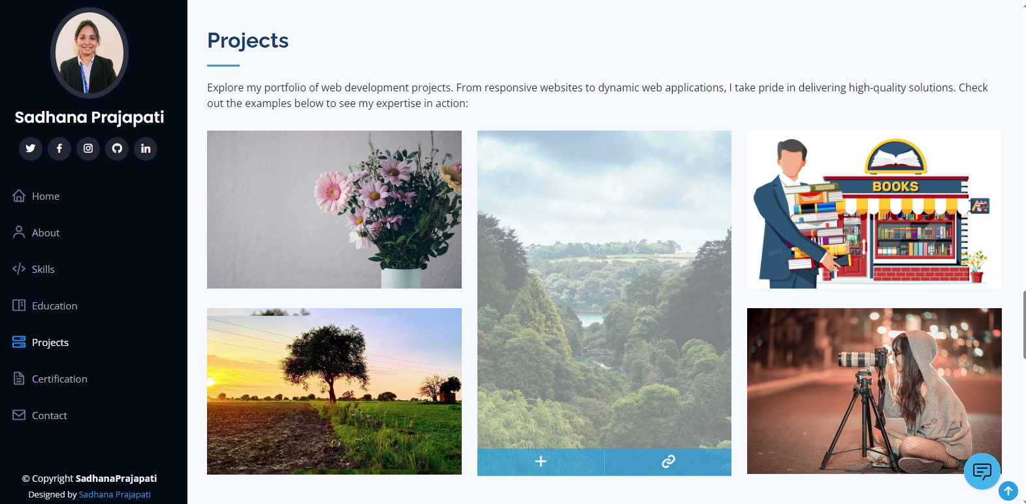

**Certification Page**

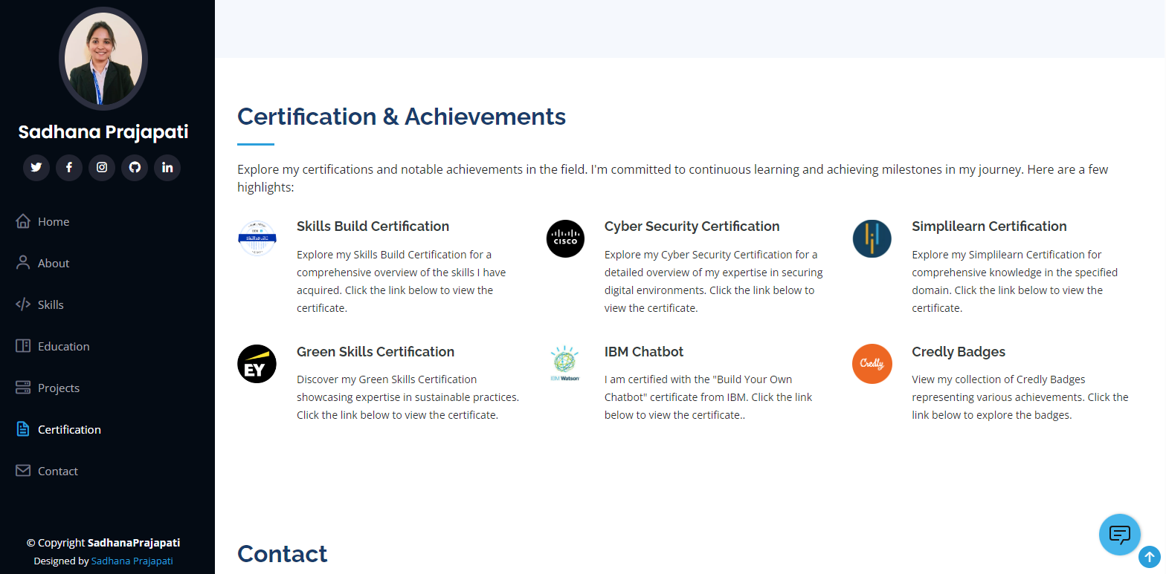

**Contact Page**

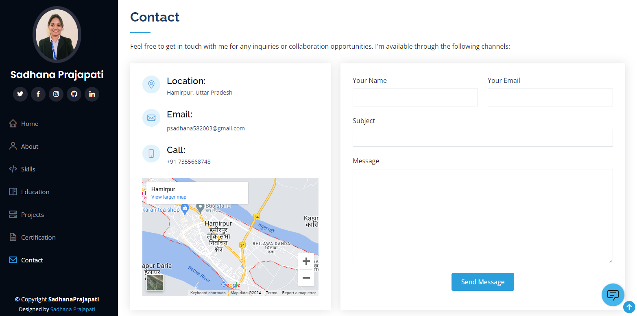

**6. CHATBOT CREATION & INTEGRATION**

**Procedure:**

**STEP 1: Login to IBM Cloud**

* Log in to IBM Cloud using your email ID and Enter your password to access the dashboard.

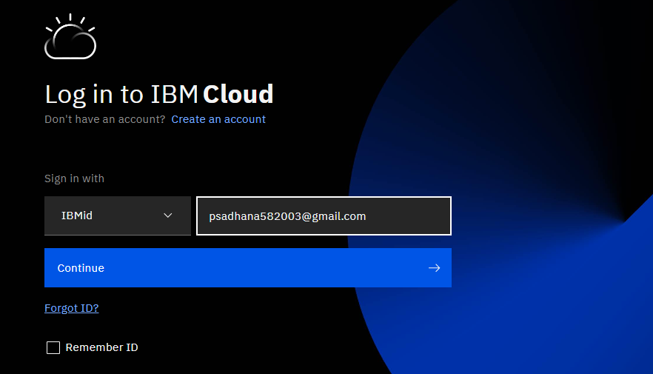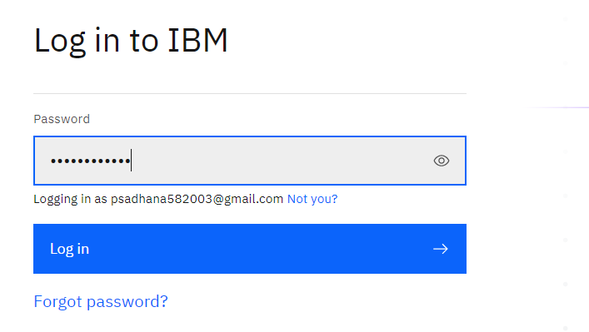

**STEP 2: Navigate to Catalog**

* Once on the dashboard, click on "Catalog."

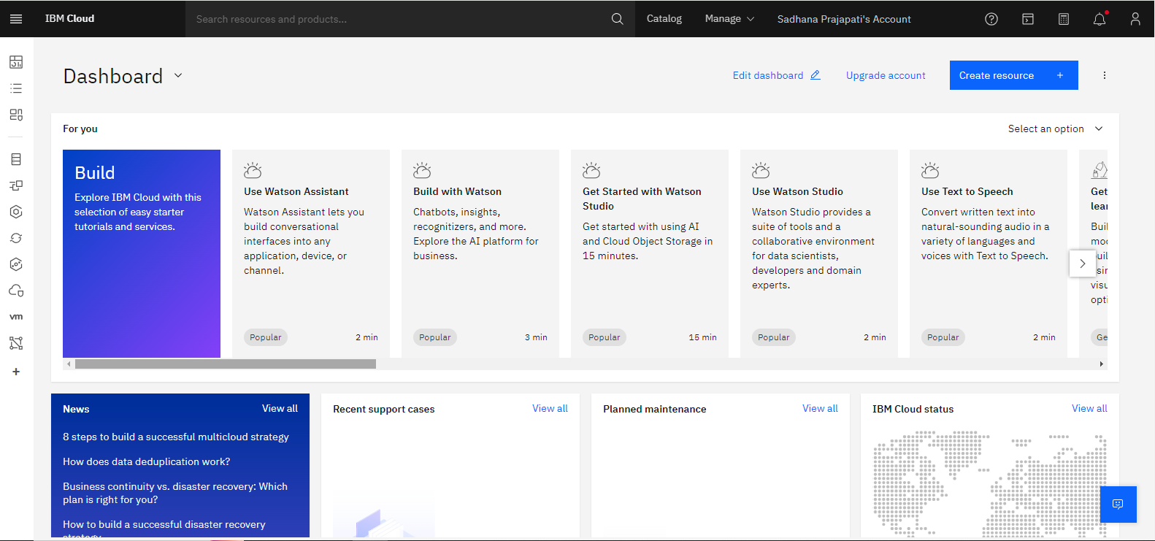

**STEP 3: Choose Watson Assistant**

* Click on "AI/Machine Learning".

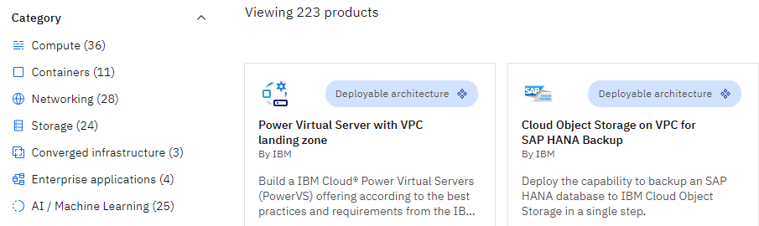

* Select "Watson Assistant."

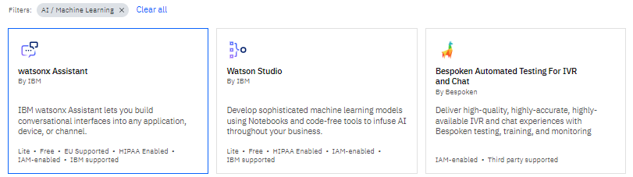

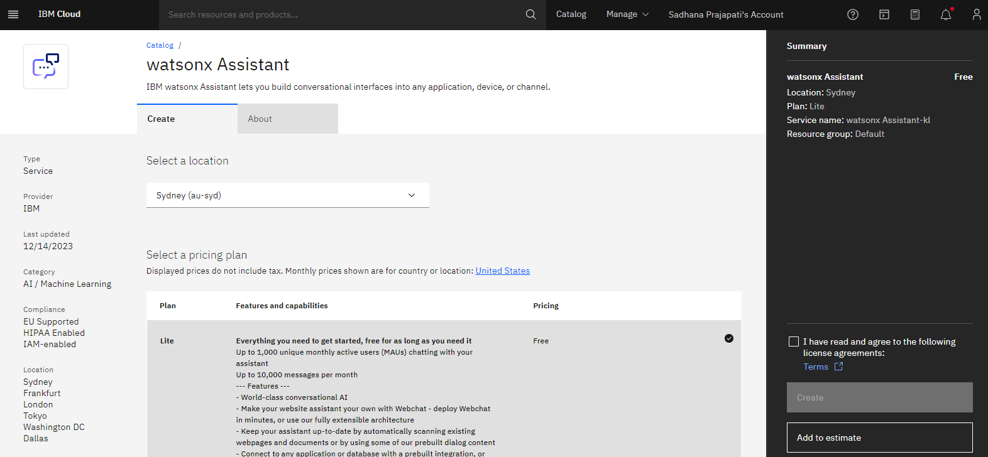

**STEP 4: Configure Watson Assistant**

* **Choose Location:** London (eu-gb).

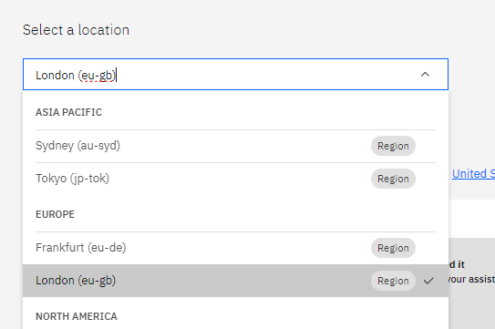

* **Select Pricing Plan:** Lite.

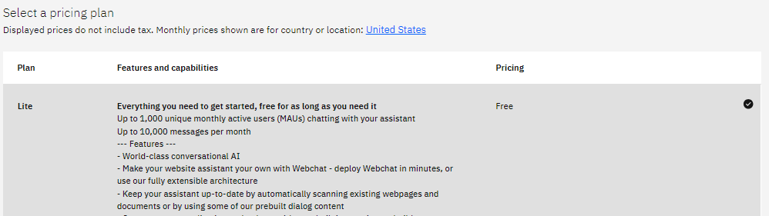

* **Configure Your Resource:**
* **Service Name:** PortFolio_ChatBot
* **Tags:** env:dev, version:1,first:resource
* **Access Management Tags:** access:developer, access:client

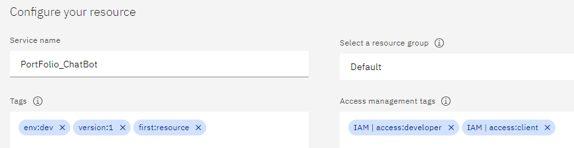

* Go to "Summary," check the box, and click "Create."

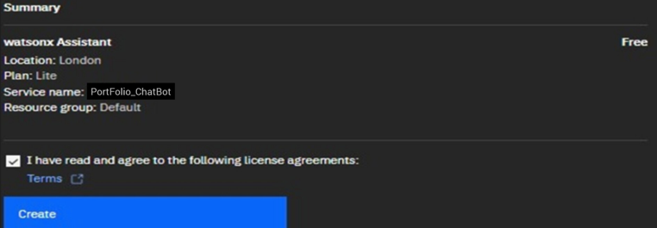

**STEP 5: Launch Watson Assistant**

* Your resource is now ready. Click "Launch Watson Assistant."

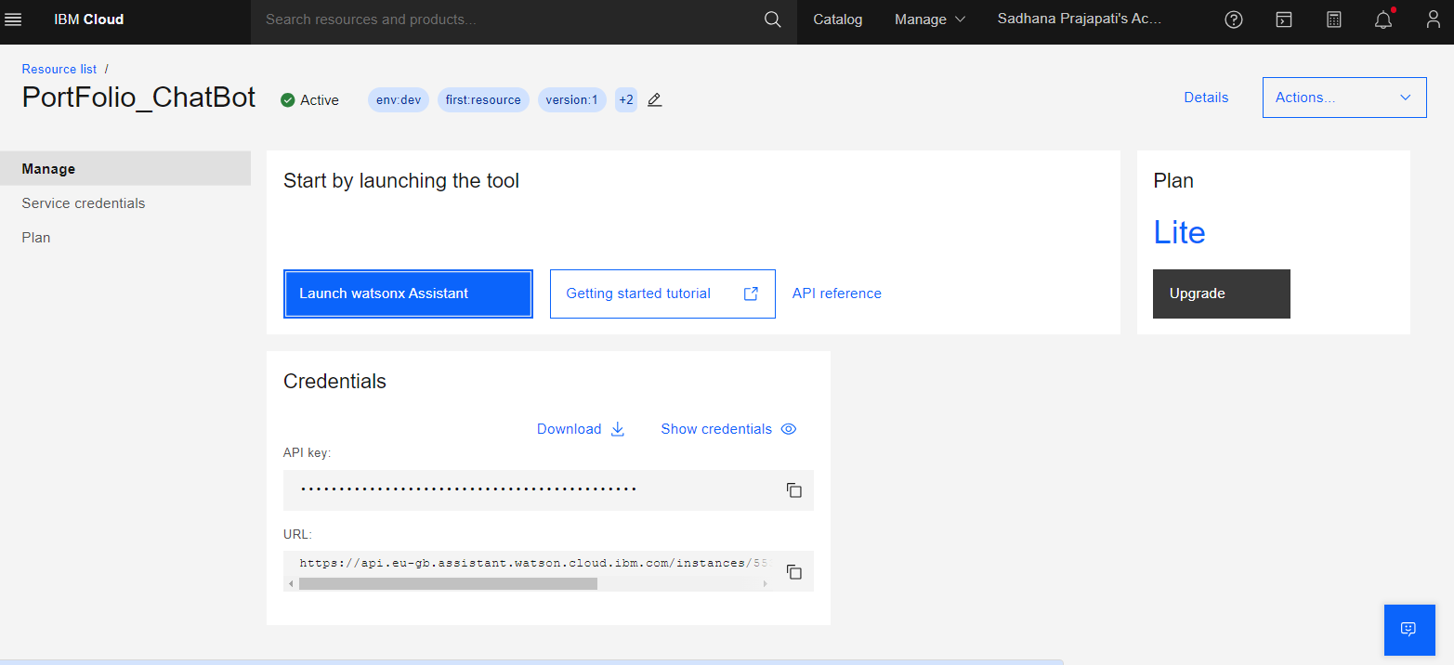

**STEP 6: Setup Chatbot**

* Provide a name for your chatbot and set the default language and then click on next button.

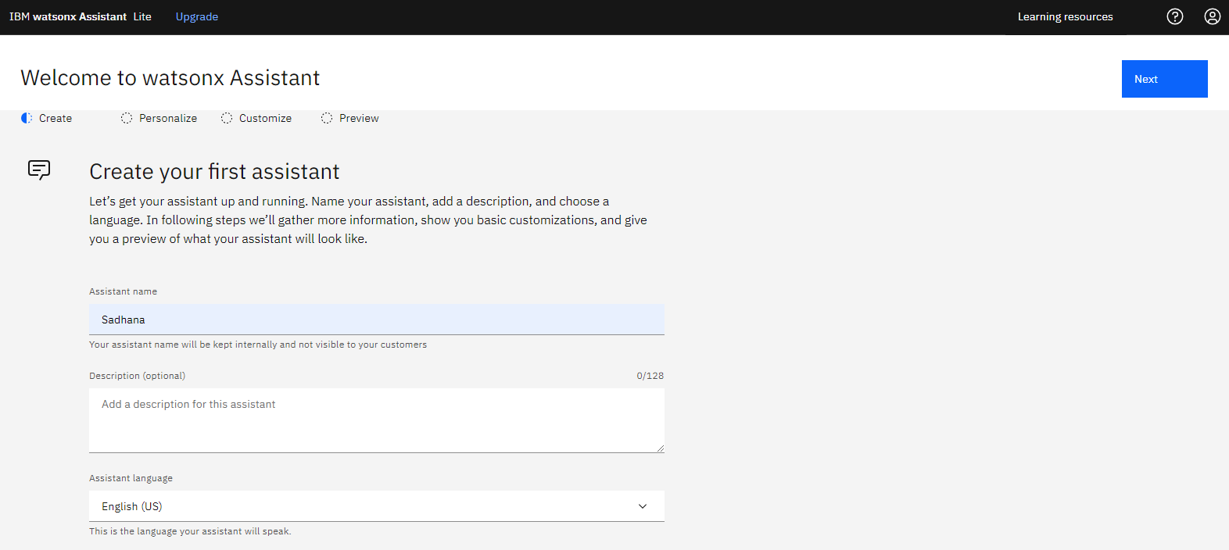

* Personalize details based on the provided image and click “Next”.

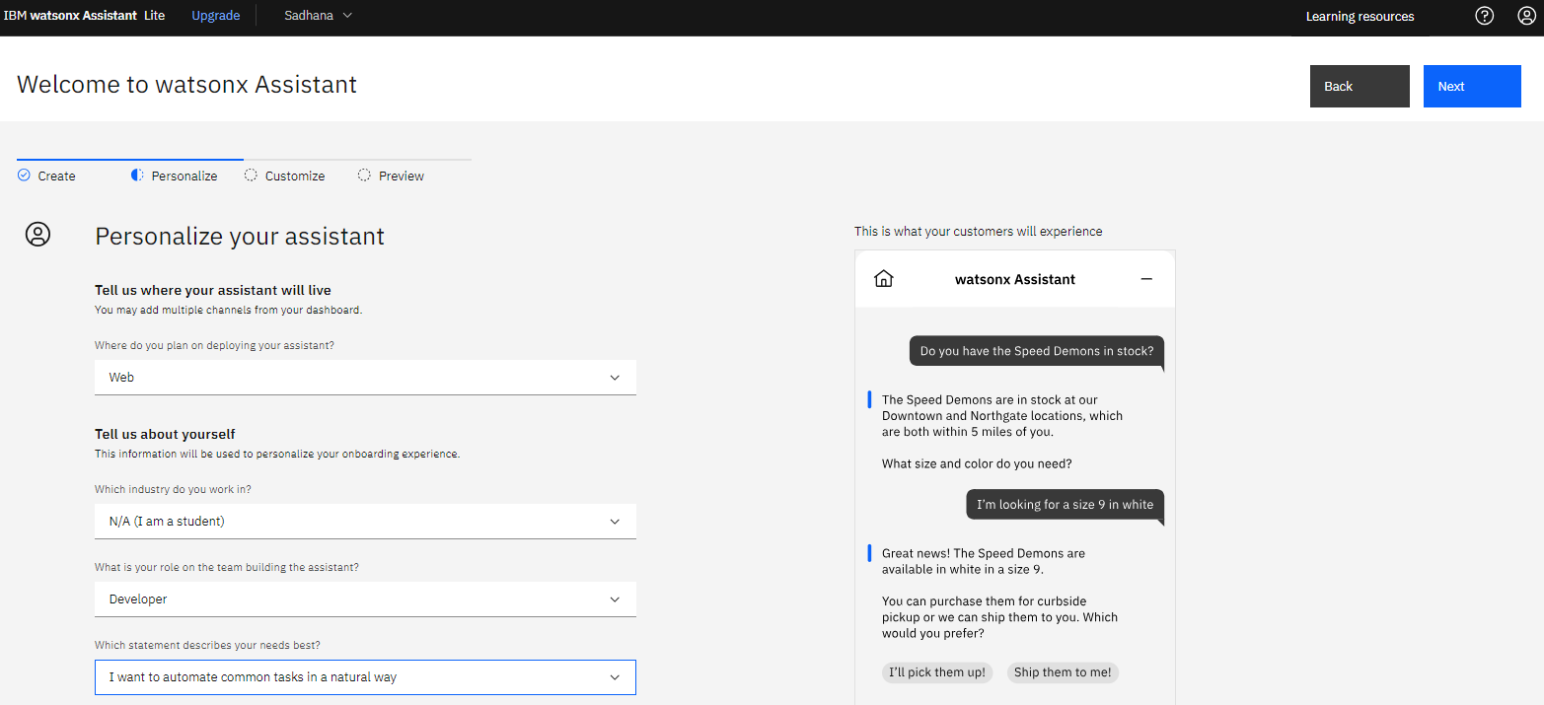

**STEP 7: Customize Chatbot**

* 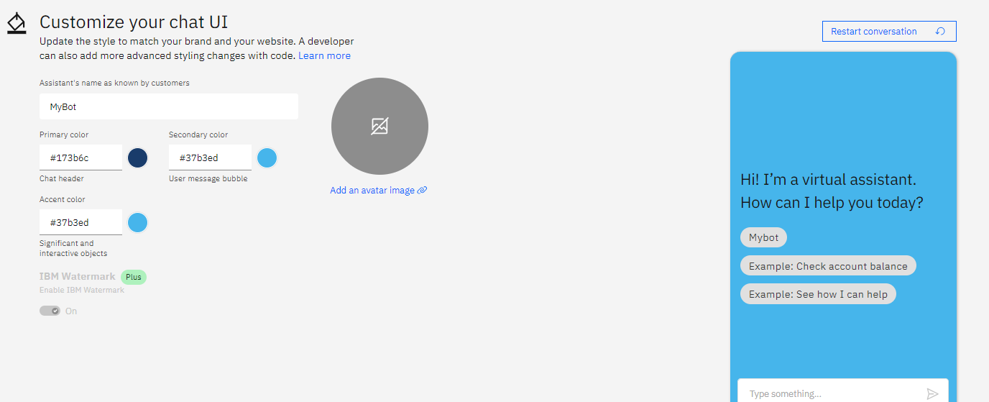Customize your chatbot settings and click "Next."

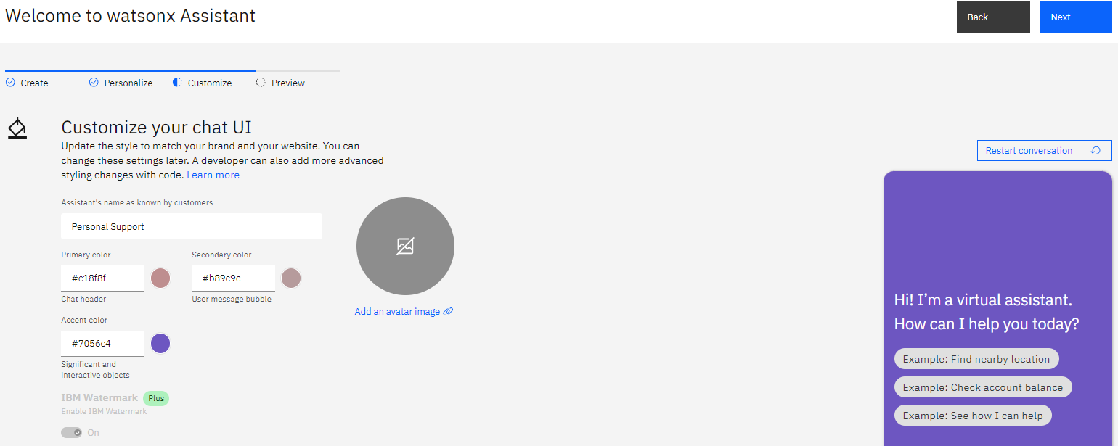

**STEP 8: Chatbot Preview**

* 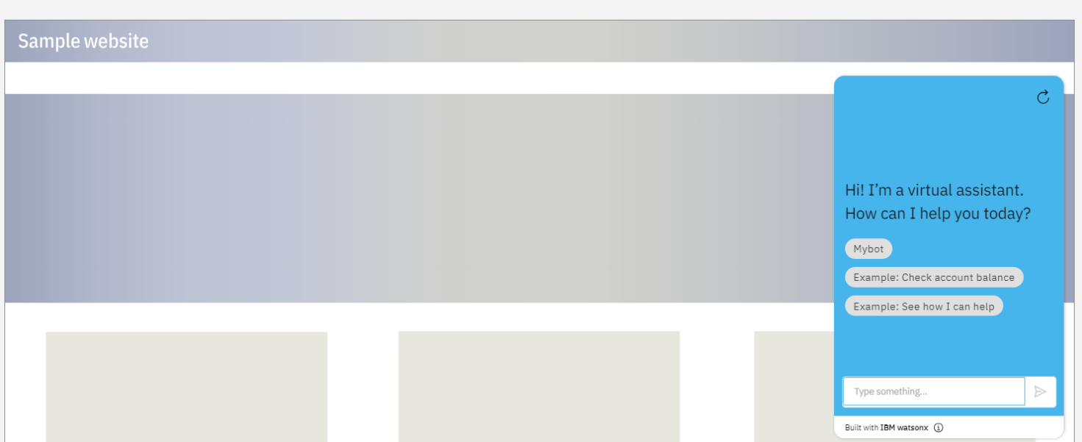Check the chatbot preview and click "Create

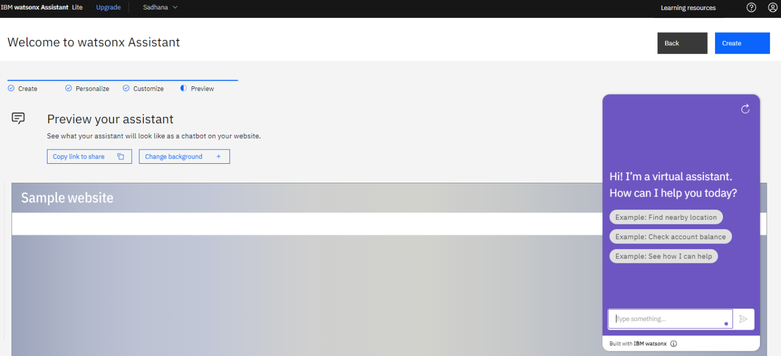

**STEP 9: Command Setup**

* Give commands to your chatbot:

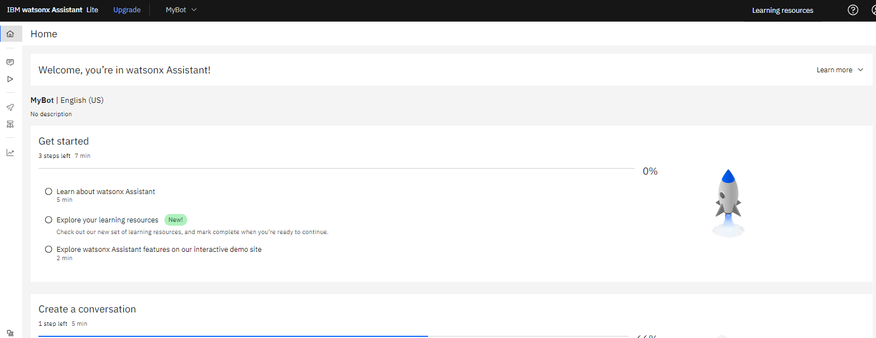

* Click on "Action Button."

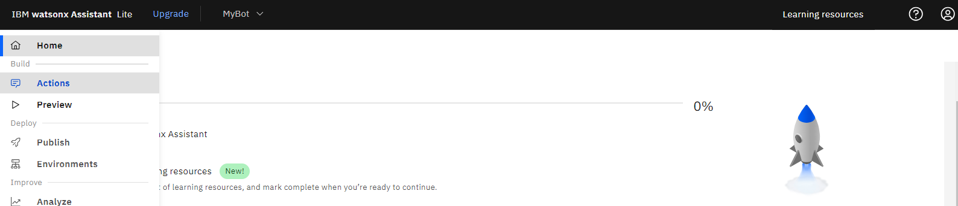

* Click on "Create Action Button."

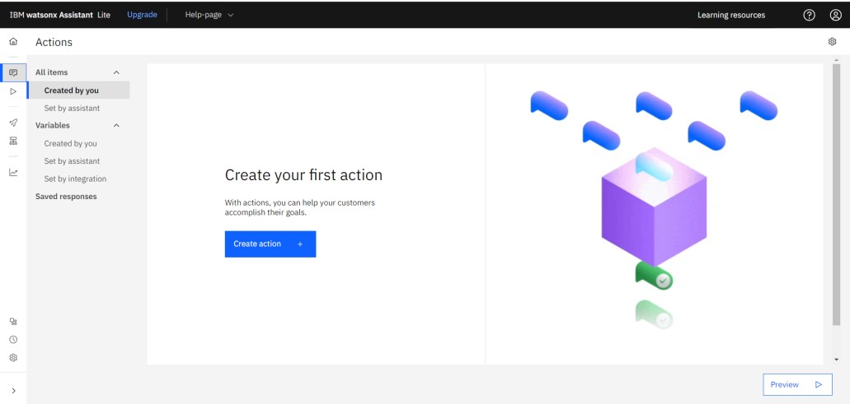

* Now click on Start from scratch.

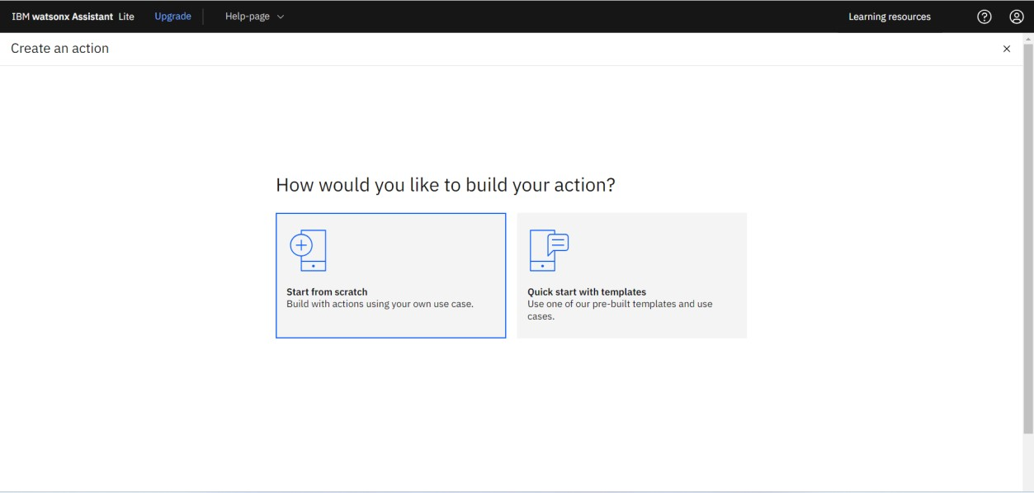

* Include keywords for user interaction.

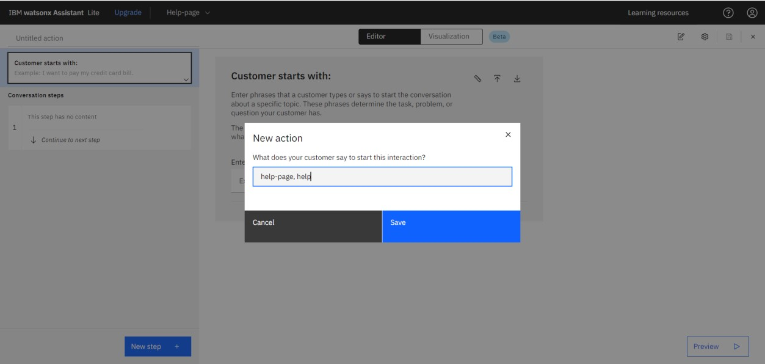

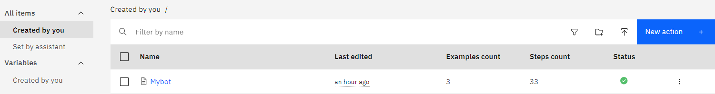

**Step 10: Add Questions and Answers:**

* Input relevant questions and answers for your chatbot.

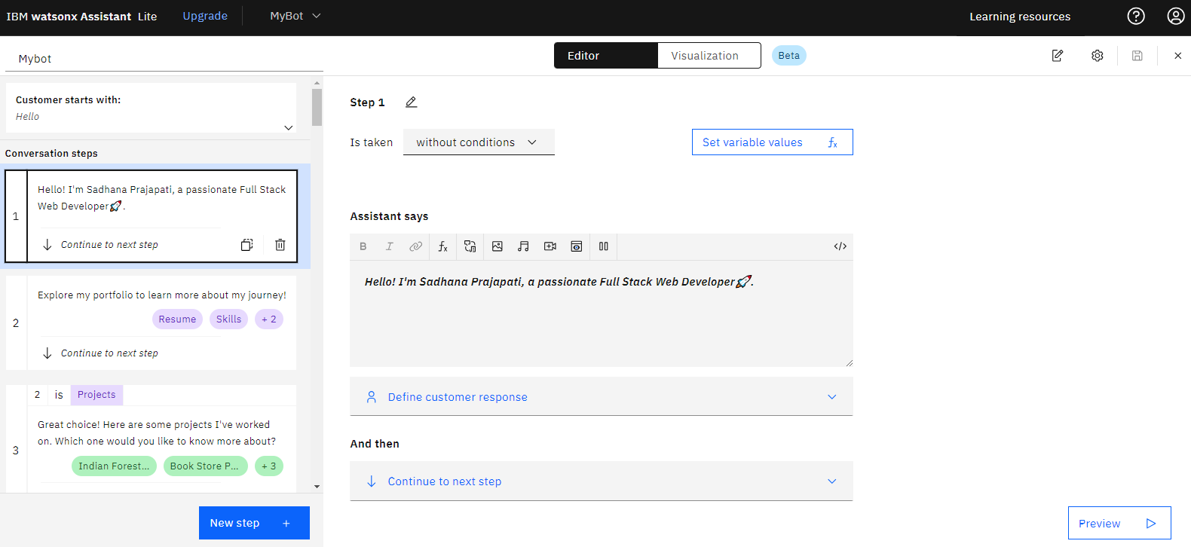

**Step 11: Click on "Integration Button":**

* After setting up your chatbot in Watson Assistant, look for an "Integration" button.

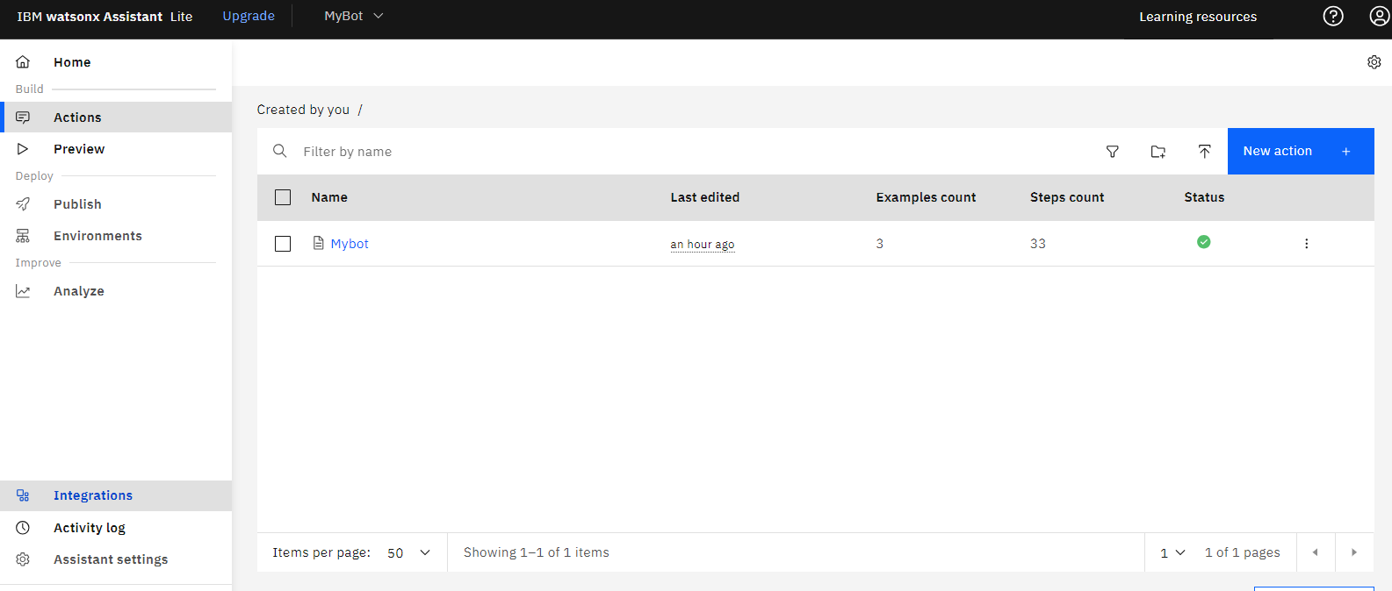

**Step 12: Go to Web Chat and Open:**

* Within the integration options, find and click on "Web Chat" and then click on "Open."

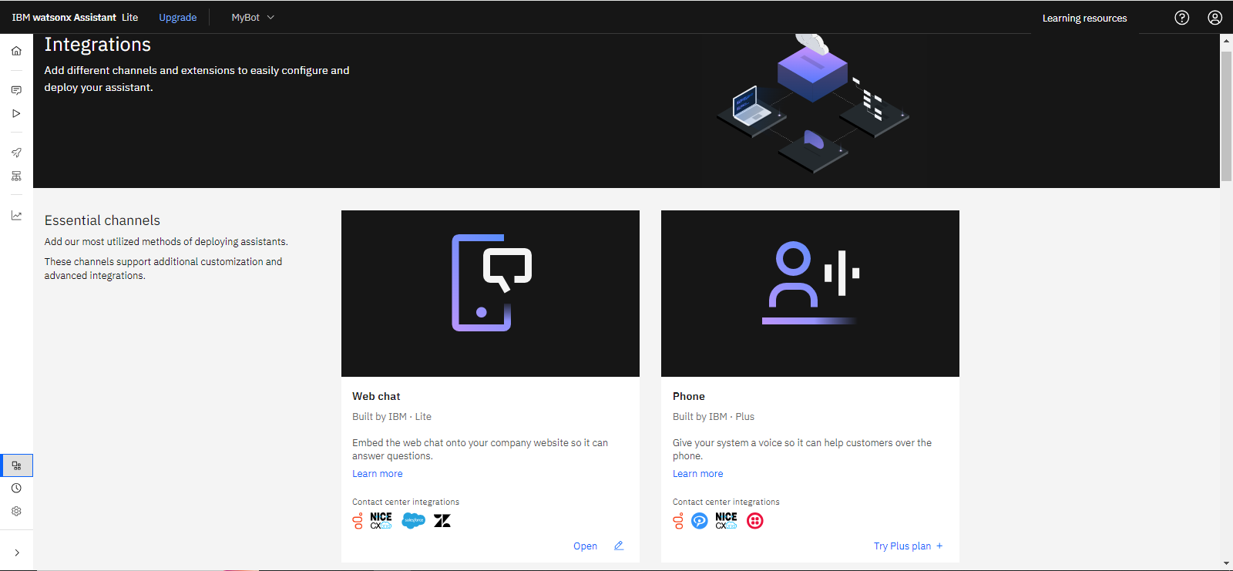

* Click on "Confirm".

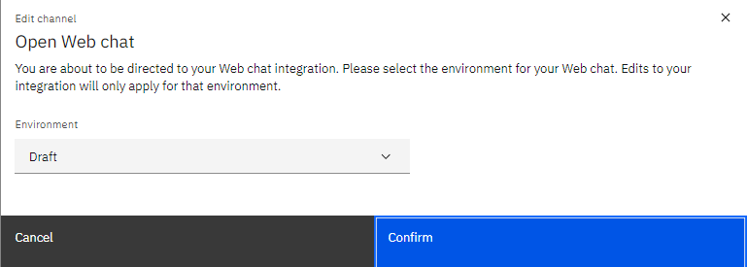

* Click on "Embed".

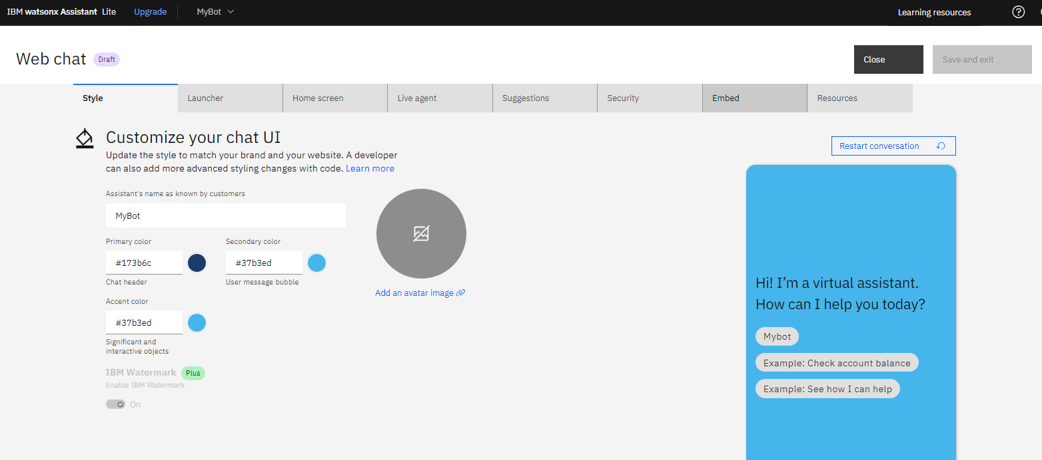

* Copy the URL.

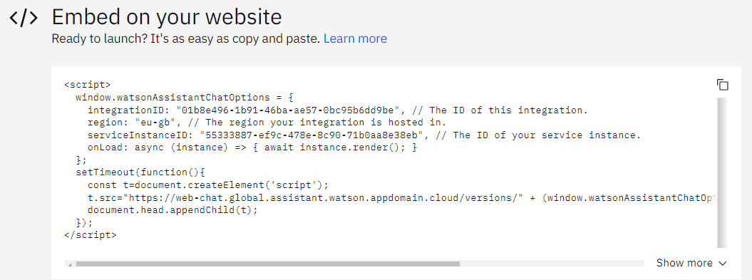

* Go to your webpage's source code and paste the copied URL to embed the chatbot.

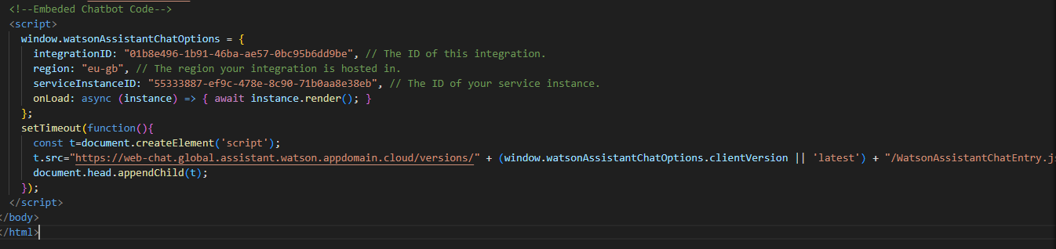

**Output:**

Your webpage should now have the embedded Watson Assistant web chat, allowing users to interact with the chatbot.

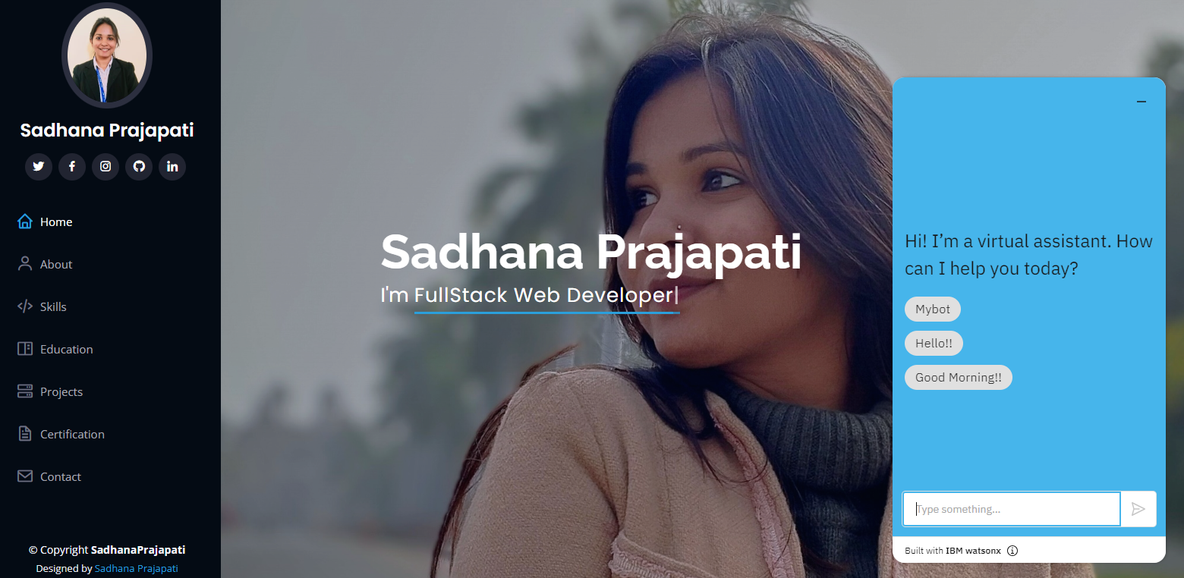

**7. HOSTING PORTFOLIO ON IBM CLOUD**

**Procedure:**

**STEP 1: Login to IBM Cloud**

* Log in to IBM Cloud using your email ID and Enter your password to access the dashboard.



**STEP 2: Navigate to Catalog**

* Once on the dashboard, click on "Catalog."



**STEP 3: Choose Storage Service**

* Click on "Storage".



* Select "Object Storage."

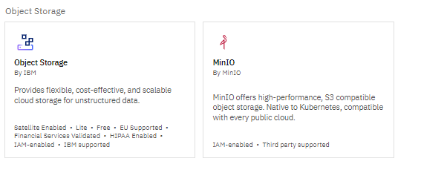

**STEP 4: Configure Object Storage**

• Select "IBM Cloud."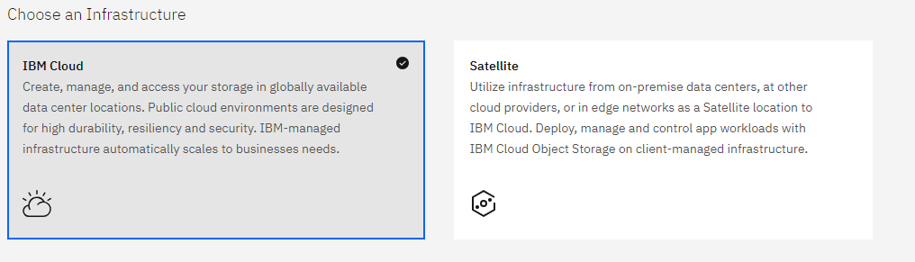

• Choose a pricing plan ”Lite”.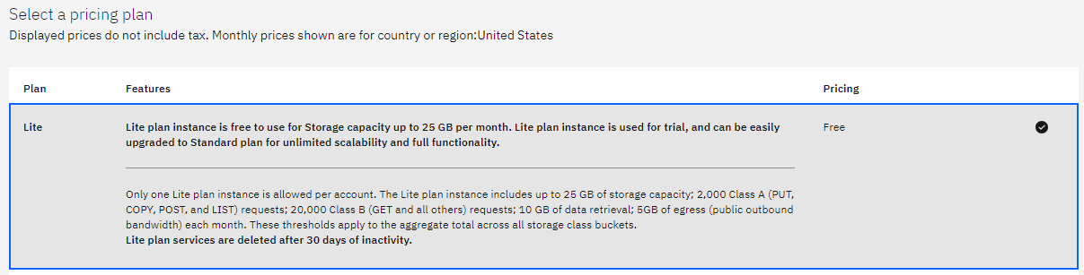

• Provide a service name and click "Create."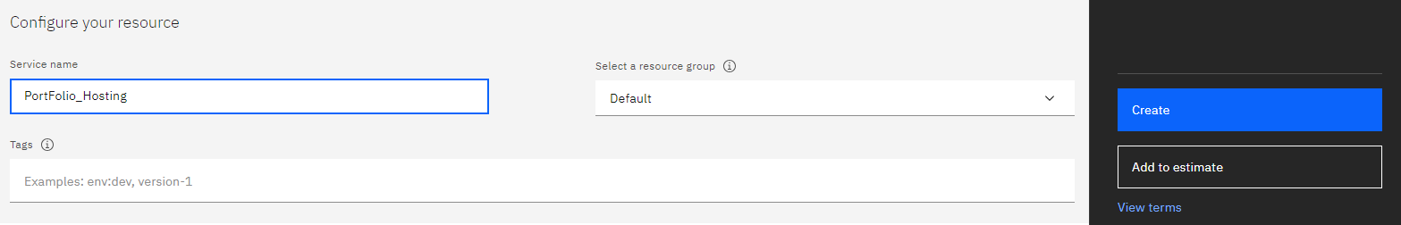

**STEP 5: Create a Bucket**

* In the new Object Storage window, scroll down and find "Create a Bucket."

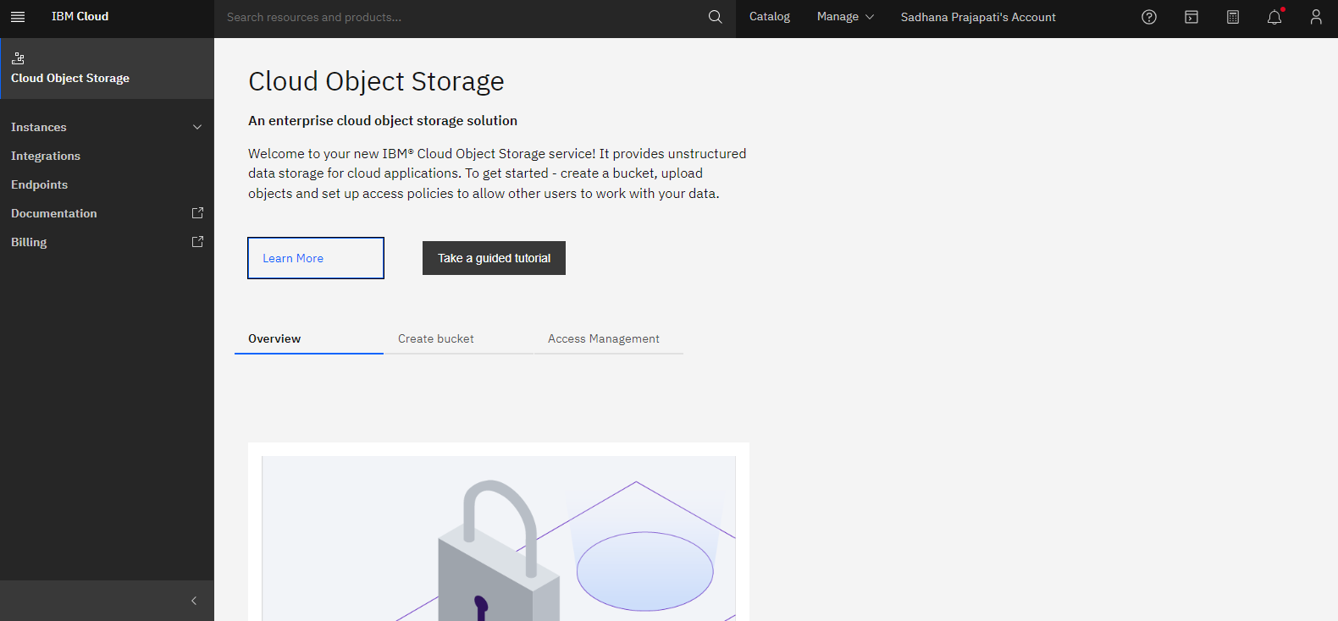

* Click "Explore" .

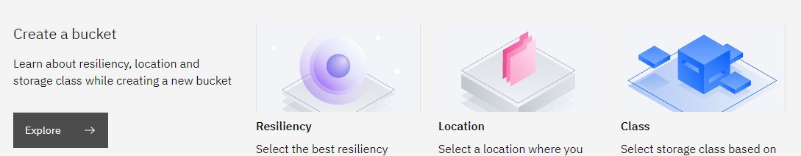

* Then “Create Bucket”.

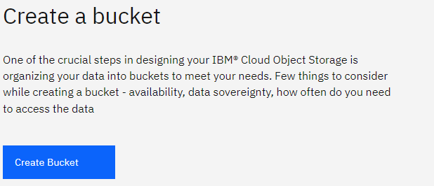

**STEP 6: Configure Bucket**

* Click "Create" under "Create a Custom Bucket."

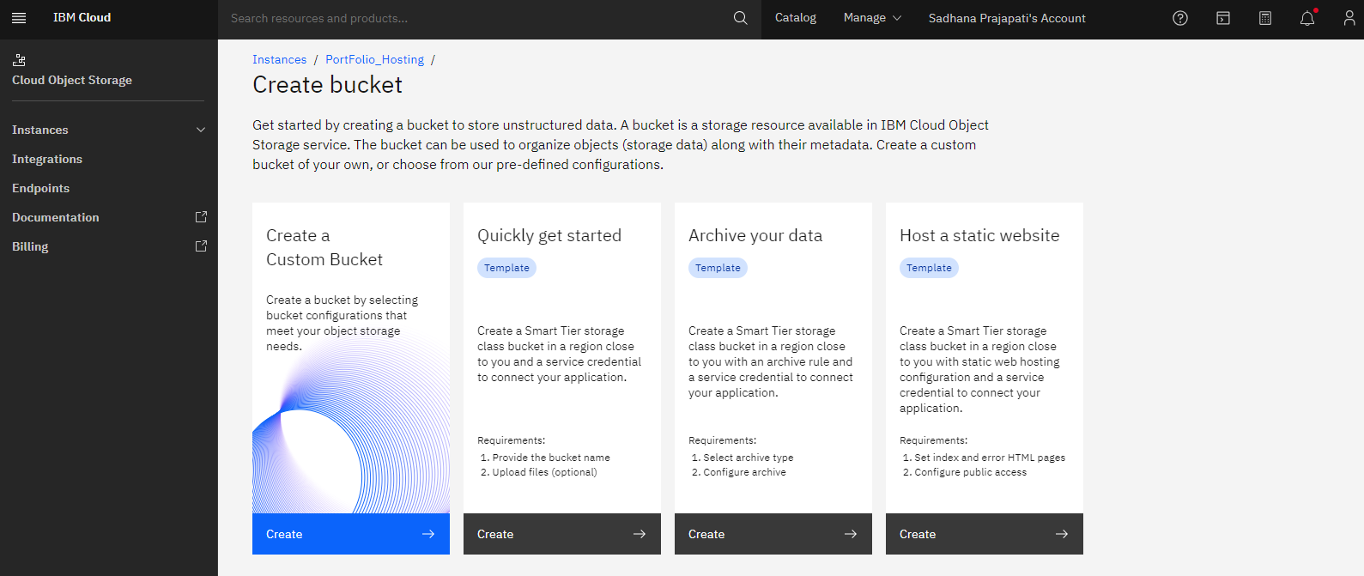

* Provide a unique name for your bucket and select the regional setting.

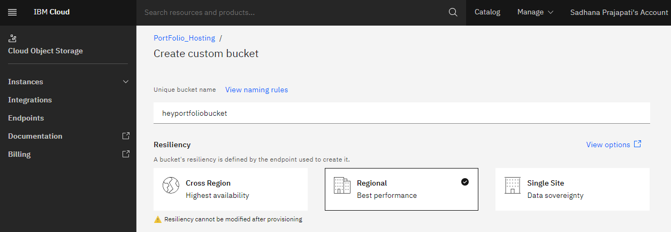

* Choose a location and enable "Smart Tier."

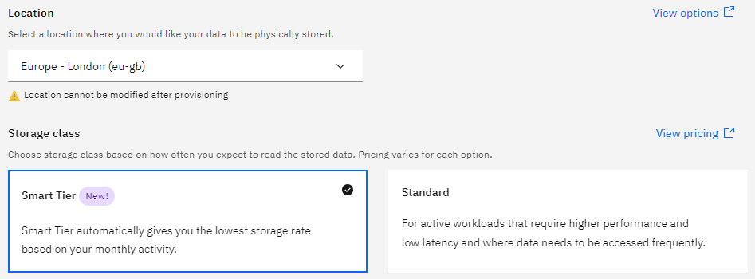

* Disable "Object Versioning" and click "Create Bucket."

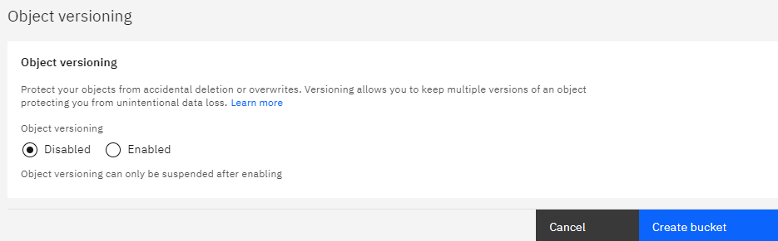

**STEP 7: Upload Files/ Folders**

* Your Object Storage is now created. Upload a file or folder
* Click "Upload."

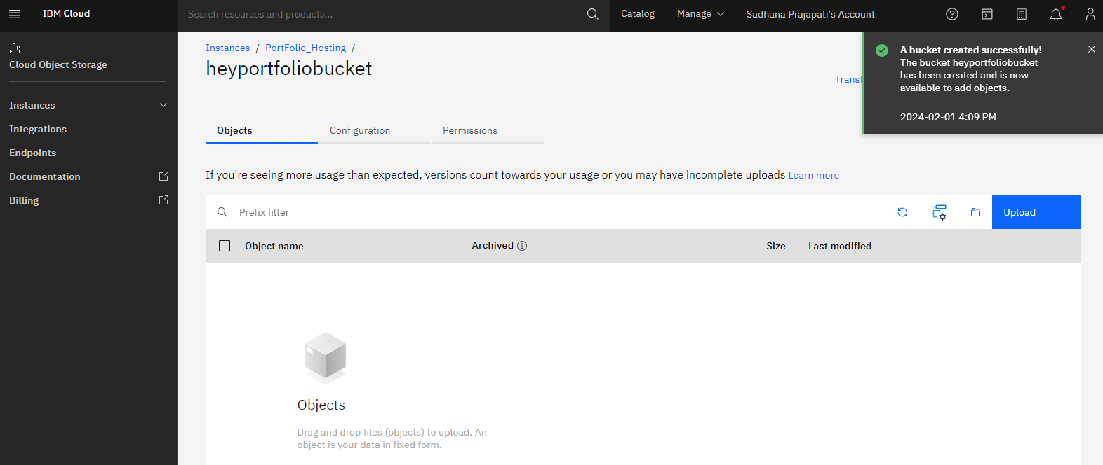

* Choose the folder or file you want to upload.

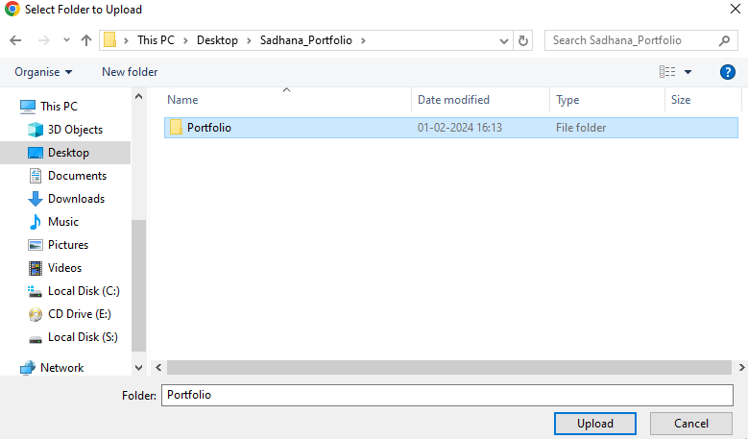

* Click on “Upload”.

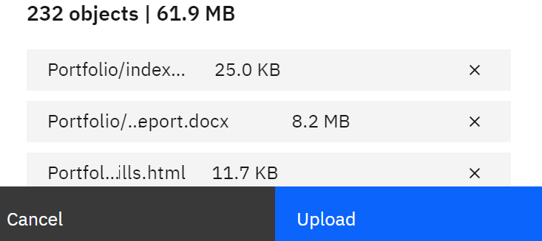

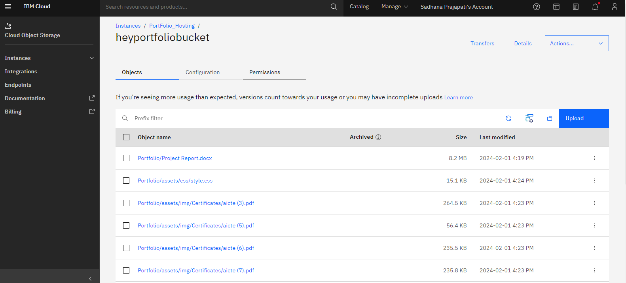

**Step 8: Grant Public Access to Your Object**

* Navigate back to the portfolio by clicking on the "PortFolio_Hosting" link.



* Locate and click on the three dots (...) for more options.

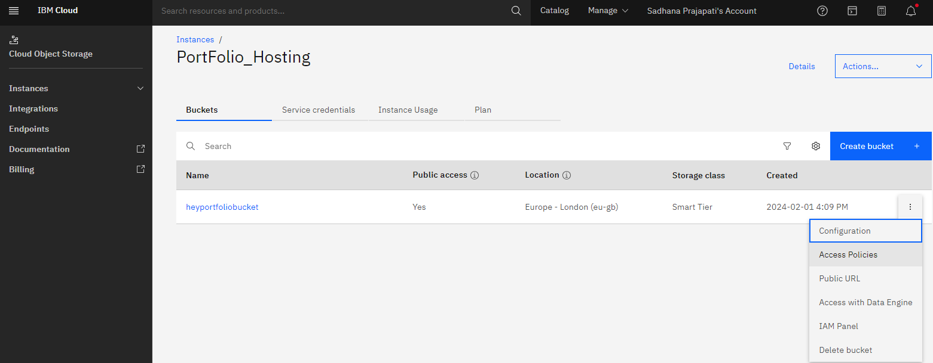

* Select "Access Policies" from the dropdown menu.



* Scroll down and click on "Public Access."
* Choose "Object Reader" as the access level.
* Click on "Create Access Policy."

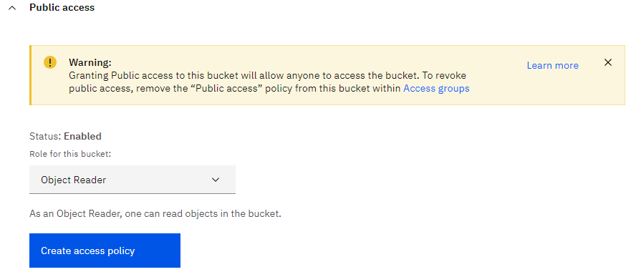

* Enable Public Access to make your HTML file accessible.

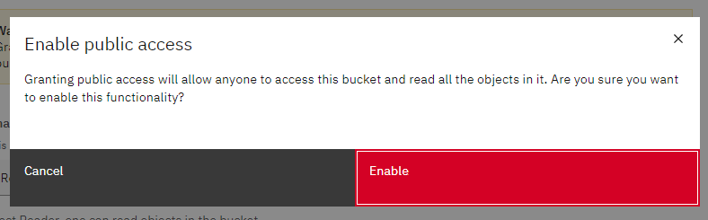

* Confirm that the access policy has been successfully created.

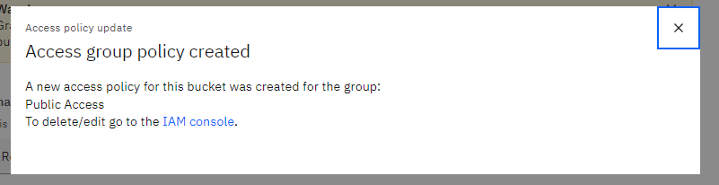

**Step 9: Obtain the Link to Your HTML File**

* Return to the object view by clicking on "PortFolio_Hosting".
* Find and click on the specific folder or file, such as "heyportfoliobucket" and then your HTML file.

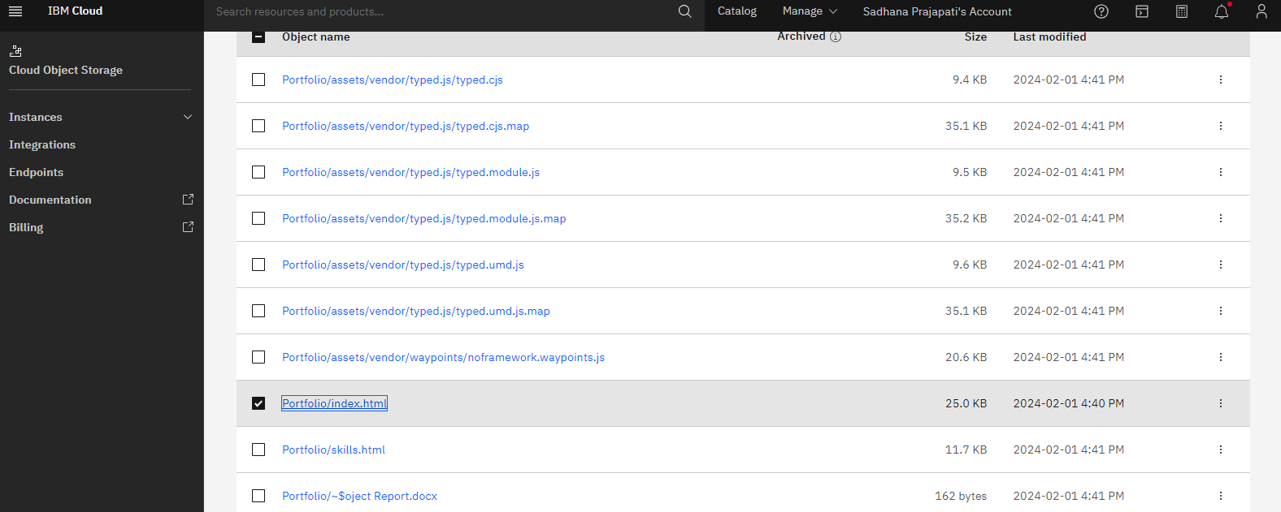

**Step 10: Copy and Access Your Application**

* Once you've opened your HTML file, a link should be generated, Copy the provided link.

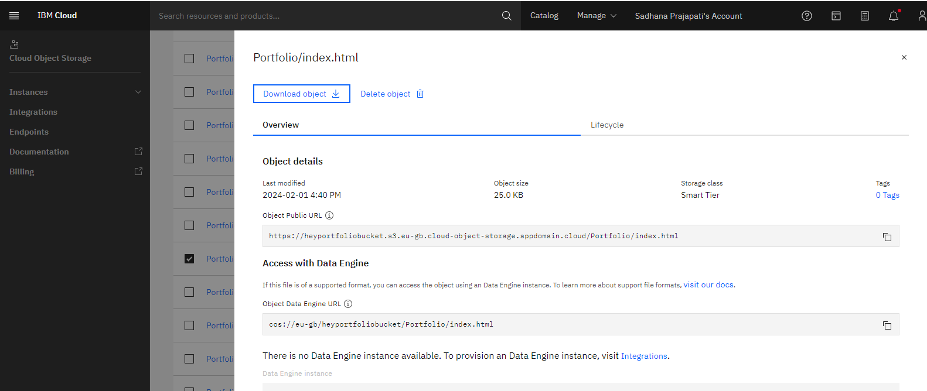

* Paste the link into your web browser's address bar, Hit Enter to access your application.

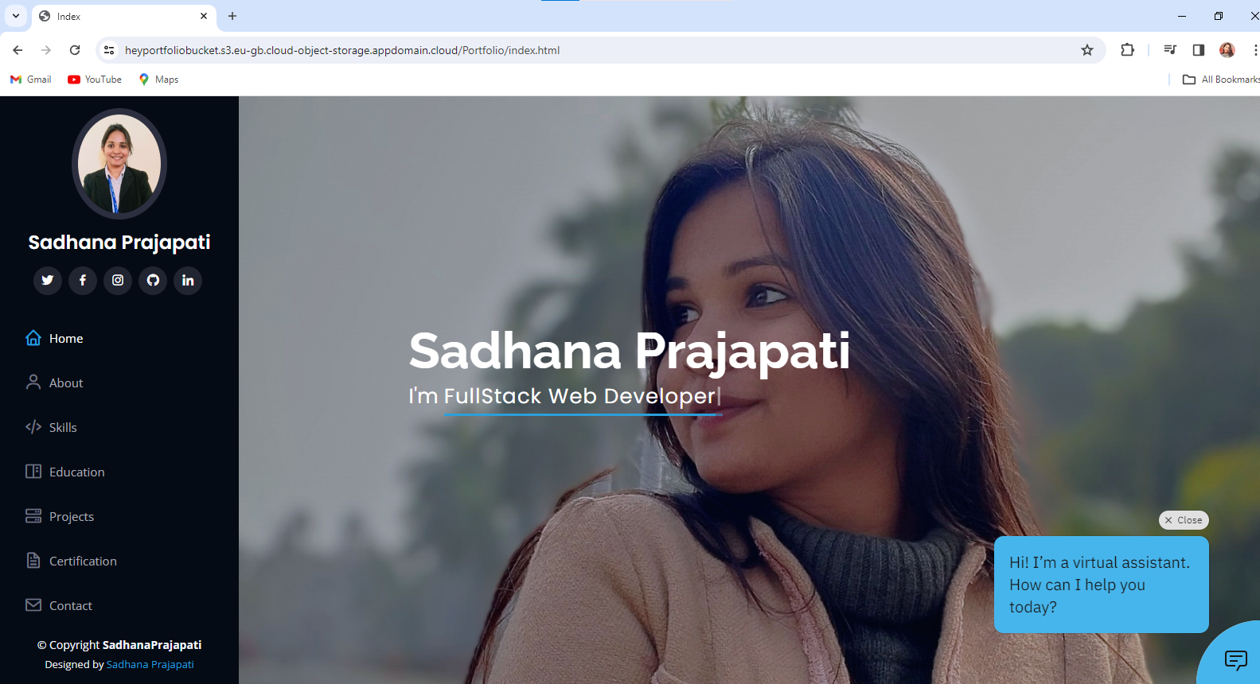

**8. SOURCE CODE**

**index.html**

<!DOCTYPE html>

<html lang="en">

<head>

  <meta charset="utf-8">

  <meta content="width=device-width, initial-scale=1.0" name="viewport">

  <title>Index</title>

  <meta content="" name="description">

  <meta content="" name="keywords">

  <link href="assets/img/apple-touch-icon.png" rel="apple-touch-icon">

  <link href="https://fonts.googleapis.com/css?family=Open+Sans:300,300i,400,400i,600,600i,700,700i|Raleway:300,300i,400,400i,500,500i,600,600i,700,700i|Poppins:300,300i,400,400i,500,500i,600,600i,700,700i" rel="stylesheet">

  <link href="assets/vendor/aos/aos.css" rel="stylesheet">

  <link href="assets/vendor/bootstrap/css/bootstrap.min.css" rel="stylesheet">

  <link href="assets/vendor/bootstrap-icons/bootstrap-icons.css" rel="stylesheet">

  <link href="assets/vendor/boxicons/css/boxicons.min.css" rel="stylesheet">

  <link href="assets/vendor/glightbox/css/glightbox.min.css" rel="stylesheet">

  <link href="assets/vendor/swiper/swiper-bundle.min.css" rel="stylesheet">

  <link href="assets/css/style.css" rel="stylesheet">

</head>

<body>

  <i class="bi bi-list mobile-nav-toggle d-xl-none"></i>

  <!-- ======= Header ======= -->

  <header id="header">

    <div class="d-flex flex-column">

      <div class="profile">

        <img src="assets/img/profile.jpeg" alt="" class="img-fluid rounded-circle">

        <h1 class="text-light"><a href="index.html">Sadhana Prajapati</a></h1>

        <div class="social-links mt-3 text-center">

          <a href="https://twitter.com/Sadhana15107119?t=96tf1lcOl6mpajUO85LN2g&s=08" class="twitter" target="_blank"><i class="bx bxl-twitter"></i></a>

          <a href="https://www.facebook.com/profile.php?id=100089482994256&mibextid=ZbWKwL" class="facebook" target="_blank"><i class="bx bxl-facebook"></i></a>

          <a href="https://instagram.com/itz_me_sadhana05?igshid=ZDdkNTZiNTM=" class="instagram" target="_blank"><i class="bx bxl-instagram"></i></a>

          <a href="https://github.com/sadhana-12345" class="github" target="_blank"><i class="bx bxl-github"></i></a>

          <a href="https://www.linkedin.com/in/sadhana-prajapati-81a18524b" class="linkedin" target="_blank"><i class="bx bxl-linkedin"></i></a>

      </div>

      </div>

      <nav id="navbar" class="nav-menu navbar">

        <ul>

          <li><a href="#hero" class="nav-link scrollto active"><i class="bx bx-home"></i> <span>Home</span></a></li>

          <li><a href="#about" class="nav-link scrollto"><i class="bx bx-user"></i> <span>About</span></a></li>

          <li><a href="#skills" class="nav-link scrollto"><i class="bx bx-code-alt"></i> <span>Skills</span></a></li>

          <li><a href="#resume" class="nav-link scrollto"><i class="bx bx-book-content"></i> <span>Education</span></a></li>

          <li><a href="#portfolio" class="nav-link scrollto"><i class="bx bx-server"></i> <span> Projects</span></a></li>

          <li><a href="#certificate" class="nav-link scrollto"><i class="bx bx-file"></i> <span>Certification</span></a></li>

          <li><a href="#contact" class="nav-link scrollto"><i class="bx bx-envelope"></i> <span>Contact</span></a></li>

        </ul>

      </nav><!-- .nav-menu -->

    </div>

  </header><!-- End Header -->

  <!-- ======= Hero Section ======= -->

  <section id="hero" class="d-flex flex-column justify-content-center align-items-center">

    <div class="hero-container" data-aos="fade-in">

      <h1>Sadhana Prajapati</h1>

      <p>I'm <span class="typed" data-typed-items="FullStack Web Developer"></span></p>

    </div>

  </section><!-- End Hero -->

  <main id="main">

    <!-- ======= About Section ======= -->

    <section id="about" class="about">

      <div class="container">

        <div class="section-title">

          <h2>About</h2>

          <p>Hello! <b>I'm Sadhana Prajapati</b>, a passionate web developer with a strong drive for success. I embody qualities such as enthusiasm, self-motivation, reliability, and a dedicated work ethic

            . As a mature team player, I thrive in collaborative environments, but I'm equally adept at taking initiative and working independently.

            Adapting to challenges comes naturally to me, and my ability to handle responsibilities makes me a valuable asset to any project. I excel under pressure, consistently meeting and exceeding strict deadlines. My commitment to excellence and innovative problem-solving defines my approach to every task.

            Join me on this journey of continuous growth and achievement in the dynamic world of web development!</p>

        </div>

        <div class="row">

          <div class="col-lg-4" data-aos="fade-right">

            <img src="assets/img/about.jpg" class="img-fluid" alt="">

          </div>

          <div class="col-lg-8 pt-4 pt-lg-0 content" data-aos="fade-left">

            <h3>Frontend & Backend &amp; Web Developer.</h3>

            <p class="fst-italic">

              I'm a web developer who loves building websites from start to finish. From making them look great on the front end to ensuring they work smoothly behind the scenes, I enjoy creating user-friendly and functional web experiences.

            </p>

            <div class="row">

              <div class="col-lg-6">

                <ul>

                  <li><i class="bi bi-chevron-right"></i> <strong>Birthday:</strong> <span>05 August 2003</span></li>

                  <li><i class="bi bi-chevron-right"></i> <strong>Email:</strong> <span>psadhana582003@gmail.com</span></li>

                  <li><i class="bi bi-chevron-right"></i> <strong>City:</strong> <span>Hamirpur</span></li>

                  <li><i class="bi bi-chevron-right"></i> <strong>Profile:</strong> <span>FullStack Web Developer</span></li>

                </ul>

              </div>

              <div class="col-lg-6">

                <ul>

                  <li><i class="bi bi-chevron-right"></i> <strong>Age:</strong> <span>19</span></li>

                  <li><i class="bi bi-chevron-right"></i> <strong>Phone:</strong> <span>+91 7355668748</span></li>

                  <li><i class="bi bi-chevron-right"></i> <strong>State:</strong> <span>Uttar Pradesh</span></li>

                  <li><i class="bi bi-chevron-right"></i> <strong>Languages:</strong> <span>Hindi, English</span></li>

                </ul>

              </div>

            </div>

            <p>

              As a dedicated web developer, I tackle challenges with passion and precision. I believe in continuous learning and innovation to deliver top-notch web solutions. My goal is to create seamless, user-friendly experiences that leave a lasting impression.

              Leveraging a blend of creativity and technical expertise, I am committed to building websites that stand out in the digital landscape.

            </p>

            <a href="assets/img/MyResume.pdf" target="_blank" class="cta-button">Download CV</a>

          </div>

          </div>

        </div>

      </div>

    </section><!-- End About Section -->

    <!-- ======= Skills Section ======= -->

    <section id="skills" class="skills section-bg">

      <div class="container">

        <div class="section-title">

          <h2>Skills</h2>

          <p>Continuously enhancing my skill set to deliver exceptional web solutions. Below are some of the technologies and tools I'm proficient in:</p>

        </div>

        <div class="row skills-content">

          <div class="col-lg-6" data-aos="fade-up">

            <div class="progress">

              <span class="skill">HTML <i class="val">100%</i></span>

              <div class="progress-bar-wrap">

                <div class="progress-bar" role="progressbar" aria-valuenow="100" aria-valuemin="0" aria-valuemax="100"></div>

              </div>

            </div>

            <div class="progress">

              <span class="skill">JavaScript <i class="val">75%</i></span>

              <div class="progress-bar-wrap">

                <div class="progress-bar" role="progressbar" aria-valuenow="75" aria-valuemin="0" aria-valuemax="100"></div>

              </div>

            </div>

            <div class="progress">

              <span class="skill">JQuery <i class="val">80%</i></span>

              <div class="progress-bar-wrap">

                <div class="progress-bar" role="progressbar" aria-valuenow="80" aria-valuemin="0" aria-valuemax="100"></div>

              </div>

            </div>

            <div class="progress">

              <span class="skill">PHP <i class="val">75%</i></span>

              <div class="progress-bar-wrap">

                <div class="progress-bar" role="progressbar" aria-valuenow="75" aria-valuemin="0" aria-valuemax="100"></div>

              </div>

            </div>

            <div class="progress">

              <span class="skill">Python <i class="val">72%</i></span>

              <div class="progress-bar-wrap">

                <div class="progress-bar" role="progressbar" aria-valuenow="72" aria-valuemin="0" aria-valuemax="100"></div>

              </div>

            </div>

            <div class="progress">

              <span class="skill">Django <i class="val">69%</i></span>

              <div class="progress-bar-wrap">

                <div class="progress-bar" role="progressbar" aria-valuenow="69" aria-valuemin="0" aria-valuemax="100"></div>

              </div>

            </div>

          </div>

          <div class="col-lg-6" data-aos="fade-up" data-aos-delay="100">

            <div class="progress">

              <span class="skill">CSS <i class="val">90%</i></span>

              <div class="progress-bar-wrap">

                <div class="progress-bar" role="progressbar" aria-valuenow="90" aria-valuemin="0" aria-valuemax="100"></div>

              </div>

            </div>

            <div class="progress">

              <span class="skill">BootStrap <i class="val">80%</i></span>

              <div class="progress-bar-wrap">

                <div class="progress-bar" role="progressbar" aria-valuenow="80" aria-valuemin="0" aria-valuemax="100"></div>

              </div>

            </div>

            <div class="progress">

              <span class="skill">MySQL <i class="val">79%</i></span>

              <div class="progress-bar-wrap">

                <div class="progress-bar" role="progressbar" aria-valuenow="79" aria-valuemin="0" aria-valuemax="100"></div>

              </div>

            </div>

            <div class="progress">

              <span class="skill">Laravel <i class="val">65%</i></span>

              <div class="progress-bar-wrap">

                <div class="progress-bar" role="progressbar" aria-valuenow="65" aria-valuemin="0" aria-valuemax="100"></div>

              </div>

            </div>

            <div class="progress">

              <span class="skill">MongoDB <i class="val">85%</i></span>

              <div class="progress-bar-wrap">

                <div class="progress-bar" role="progressbar" aria-valuenow="85" aria-valuemin="0" aria-valuemax="100"></div>

              </div>

            </div>

            <div class="progress">

              <span class="skill">Flask <i class="val">40%</i></span>

              <div class="progress-bar-wrap">

                <div class="progress-bar" role="progressbar" aria-valuenow="40" aria-valuemin="0" aria-valuemax="100"></div>

              </div>

            </div>

          </div>

        </div>

      </div>

    </section><!-- End Skills Section -->

    <!-- ======= Education Section ======= -->

    <section id="resume" class="resume">

      <div class="container">

        <div class="section-title">

          <h2>Education</h2>

          <p>Continuing my educational journey to acquire knowledge and skills. Here are the details of my academic achievements:</p>

        </div>

            <div class="resume-item">

              <h4>Advance Diploma In IT Networking & Cloud Computing</h4>

              <h5>2022 - Present</h5>

              <p><em>National Skill Training Institue Women ,Noida</em></p>

              <p>Currently pursuing a diploma in IT with a focus on web development and software engineering. Acquiring in-depth knowledge of algorithms, data structures, and programming languages.</p>

            </div>

            <div class="resume-item">

              <h4>Higher-Secondary Certificate</h4>

              <h5>2020 - 2021</h5>

              <p><em>University Of Prayagraj</em></p>

              <p>Completed my Higher-Secondary education with a specialization in Science. Developed a strong foundation in mathematics, physics, and chemistry, laying the groundwork for my academic pursuits.</p>

            </div>

            <div class="resume-item">

              <h4>Secondary School Certificate</h4>

              <h5>2018 - 2019</h5>

              <p><em>University Of Prayagraj</em></p>

              <p>Attained my Secondary School Certificate with a focus on a well-rounded curriculum. Developed critical thinking and problem-solving skills during this foundational stage of my education.</p>

            </div>

            <h3 class="resume-title">Experience</h3>

            <div class="resume-item">

              <p><em>Fresher</em></p>

            </div>

          </div>

        </div>

      </div>

    </section><!-- End Resume Section -->

    <!-- ======= Portfolio Section ======= -->

    <section id="portfolio" class="portfolio section-bg">

      <div class="container">

        <div class="section-title">

          <h2>Projects</h2>

          <p>Explore my portfolio of web development projects. From responsive websites to dynamic web applications, I take pride in delivering high-quality solutions. Check out the examples below to see my expertise in action:</p>

        </div>

        <div class="row portfolio-container" data-aos="fade-up" data-aos-delay="100">

          <div class="col-lg-4 col-md-6 portfolio-item filter-app">

            <div class="portfolio-wrap">

              <img src="assets/img/portfolio/project1.jpg" class="img-fluid" alt="">

              <div class="portfolio-links">

                <a href="assets/img/portfolio/project1.jpg" data-gallery="portfolioGallery" class="portfolio-lightbox" title="Web Development"><i class="bx bx-plus"></i></a>

                <a href="https://flowerwebsitesadhana.000webhostapp.com/" title="More Details"><i class="bx bx-link"></i></a>

              </div>

            </div>

          </div>

          <div class="col-lg-4 col-md-6 portfolio-item filter-web">

            <div class="portfolio-wrap">

              <img src="assets/img/portfolio/project3.jpg" class="img-fluid" alt="">

              <div class="portfolio-links">

                <a href="assets/img/portfolio/project3.jpg" data-gallery="portfolioGallery" class="portfolio-lightbox" title="Web Development"><i class="bx bx-plus"></i></a>

                <a href="https://sadhana-12345.github.io/Indian_Forest/" title="More Details"><i class="bx bx-link"></i></a>

              </div>

            </div>

          </div>

          <div class="col-lg-4 col-md-6 portfolio-item filter-app">

            <div class="portfolio-wrap">

              <img src="assets/img/portfolio/project2.png" class="img-fluid" alt="">

              <div class="portfolio-links">

                <a href="assets/img/portfolio/project2.png" data-gallery="portfolioGallery" class="portfolio-lightbox" title="Web Development"><i class="bx bx-plus"></i></a>

                <a href="https://sadhana-12345.github.io/BookZone/"title="More Details"><i class="bx bx-link"></i></a>

              </div>

            </div>

          </div>

          <div class="col-lg-4 col-md-6 portfolio-item filter-card">

            <div class="portfolio-wrap">

              <img src="assets/img/portfolio/project4.jpeg" class="img-fluid" alt="">

              <div class="portfolio-links">

                <a href="assets/img/portfolio/project4.jpeg" data-gallery="portfolioGallery" class="portfolio-lightbox" title="Web Development"><i class="bx bx-plus"></i></a>

                <a href="#" title="More Details"><i class="bx bx-link"></i></a>

              </div>

            </div>

          </div>

          <div class="col-lg-4 col-md-6 portfolio-item filter-web">

            <div class="portfolio-wrap">

              <img src="assets/img/portfolio/project5.jpg" class="img-fluid" alt="">

              <div class="portfolio-links">

                <a href="assets/img/portfolio/project5.jpg" data-gallery="portfolioGallery" class="portfolio-lightbox" title="Web Development"><i class="bx bx-plus"></i></a>

                <a href="https://sadhana-12345.github.io/PhotoFolio_Project/" title="More Details"><i class="bx bx-link"></i></a>

              </div>

            </div>

          </div>

        </div>

      </div>

    </section><!-- End Portfolio Section -->

    <!-- ======= Certificates Section ======= -->

    <section id="certificate" class="certificate">

      <div class="container">

        <div class="section-title">

          <h2>Certification & Achievements</h2>

          <p>Explore my certifications and notable achievements in the field. I'm committed to continuous learning and achieving milestones in my journey. Here are a few highlights:</p>

        </div>

        <div class="row">

          <div class="col-lg-4 col-md-6 icon-box" data-aos="fade-up">

            <div class="icon"><img src="assets/img/logo1.png" alt="Your Logo"></div>

            <h4 class="title"><a href="skills.html" target="_blank">Skills Build Certification</a></h4>

            <p class="description">Explore my Skills Build Certification for a comprehensive overview of the skills I have acquired. Click the link below to view the certificate.</p>

        </div>

        <div class="col-lg-4 col-md-6 icon-box" data-aos="fade-up" data-aos-delay="100">

          <div class="icon"><img src="assets/img/logo2.jpg" alt="Your Logo"></div>

          <h4 class="title"><a href="assets/img/Certificates/cyber.pdf" target="_blank">Cyber Security Certification</a></h4>

          <p class="description">Explore my Cyber Security Certification for a detailed overview of my expertise in securing digital environments. Click the link below to view the certificate.</p>

        </div>

        <div class="col-lg-4 col-md-6 icon-box" data-aos="fade-up" data-aos-delay="200">

        <div class="icon"><img src="assets/img/logo3.jpg" alt="Simplilearn Logo"></div>

        <h4 class="title"><a href="assets/img/Certificates/simplilearn.pdf" target="_blank">Simplilearn Certification</a></h4>

        <p class="description">Explore my Simplilearn Certification for comprehensive knowledge in the specified domain. Click the link below to view the certificate.</p>

        </div>

        <div class="col-lg-4 col-md-6 icon-box" data-aos="fade-up" data-aos-delay="300">

        <div class="icon"><img src="assets/img/logo4.jpg" alt="Green Skills Logo"></div>

        <h4 class="title"><a href="assets/img/Certificates/greenskills.pdf" target="_blank">Green Skills Certification</a></h4>

        <p class="description">Discover my Green Skills Certification showcasing expertise in sustainable practices. Click the link below to view the certificate.</p>

        </div>

        <div class="col-lg-4 col-md-6 icon-box" data-aos="fade-up" data-aos-delay="400">

        <div class="icon"><img src="assets/img/logo5.jpg" alt="IBM ChatBot Logo"></div>

        <h4 class="title"><a href="assets/img/Certificates/ibmchatbot.pdf" target="_blank">IBM Chatbot </a></h4>

        <p class="description">I am certified with the "Build Your Own Chatbot" certificate from IBM. Click the link below to view the certificate..</p>

        </div>

        <div class="col-lg-4 col-md-6 icon-box" data-aos="fade-up" data-aos-delay="500">

        <div class="icon"><img src="assets/img/logo6.png" alt="Credly Badges Logo"></div>

        <h4 class="title"><a href="https://www.credly.com/users/sadhana-prajapati/badges" target="_blank">Credly Badges</a></h4>

        <p class="description">View my collection of Credly Badges representing various achievements. Click the link below to explore the badges.</p>

        </div>

      </div>

    </section><!-- End Certificates Section -->

    <!-- ======= Contact Section ======= -->

    <section id="contact" class="contact">

      <div class="container">

        <div class="section-title">

          <h2>Contact</h2>

          <p>Feel free to get in touch with me for any inquiries or collaboration opportunities. I'm available through the following channels:</p>

        </div>

        <div class="row" data-aos="fade-in">

          <div class="col-lg-5 d-flex align-items-stretch">

            <div class="info">

              <div class="address">

                <i class="bi bi-geo-alt"></i>

                <h4>Location:</h4>

                <p>Hamirpur, Uttar Pradesh</p>

              </div>

              <div class="email">

                <i class="bi bi-envelope"></i>

                <h4>Email:</h4>

                <p>psadhana582003@gmail.com</p>

              </div>

              <div class="phone">

                <i class="bi bi-phone"></i>

                <h4>Call:</h4>

                <p>+91 7355668748</p>

              </div>

              <iframe src="https://www.google.com/maps/embed?pb=!1m18!1m12!1m3!1d14349.623547573909!2d80.1552415!3d25.9547256!2m3!1f0!2f0!3f0!3m2!1i1024!2i768!4f13.1!3m3!1m2!1s0x399cfc4d8f74b8f1%3A0x83bcd20cf41b3b2b!2sHamirpur%2C%20Uttar%20Pradesh%20210301!5e0!3m2!1sen!2sin!4v1706501872002!5m2!1sen!2sin"  frameborder="0" style="border:0; width: 100%; height: 290px;" allowfullscreen></iframe>

            </div>

          </div>

          <div class="col-lg-7 mt-5 mt-lg-0 d-flex align-items-stretch">

            <form action="#" method="post" role="form" class="php-email-form">

              <div class="row">

                <div class="form-group col-md-6">

                  <label for="name">Your Name</label>

                  <input type="text" name="name" class="form-control" id="name" required>

                </div>

                <div class="form-group col-md-6">

                  <label for="name">Your Email</label>

                  <input type="email" class="form-control" name="email" id="email" required>

                </div>

              </div>

              <div class="form-group">

                <label for="name">Subject</label>

                <input type="text" class="form-control" name="subject" id="subject" required>

              </div>

              <div class="form-group">

                <label for="name">Message</label>

                <textarea class="form-control" name="message" rows="10" required></textarea>

              </div>

              <div class="my-3">

                <div class="loading">Loading</div>

                <div class="error-message"></div>

                <div class="sent-message">Your message has been sent. Thank you!</div>

              </div>

              <div class="text-center"><button type="submit">Send Message</button></div>

            </form>

          </div>

        </div>

      </div>

    </section><!-- End Contact Section -->

  </main><!-- End #main -->

  <!-- ======= Footer ======= -->

  <footer id="footer">

    <div class="container">

      <div class="copyright">

        &copy; Copyright <strong><span>SadhanaPrajapati</span></strong>

      </div>

      <div class="credits">

        Designed by <a href="#">Sadhana Prajapati</a>

      </div>

    </div>

  </footer><!-- End  Footer -->

  <a href="#" class="back-to-top d-flex align-items-center justify-content-center"><i class="bi bi-arrow-up-short"></i></a>

  </script>

  <!-- Vendor JS Files -->

  <script src="assets/vendor/purecounter/purecounter_vanilla.js"></script>

  <script src="assets/vendor/aos/aos.js"></script>

  <script src="assets/vendor/bootstrap/js/bootstrap.bundle.min.js"></script>

  <script src="assets/vendor/glightbox/js/glightbox.min.js"></script>

  <script src="assets/vendor/isotope-layout/isotope.pkgd.min.js"></script>

  <script src="assets/vendor/swiper/swiper-bundle.min.js"></script>

  <script src="assets/vendor/typed.js/typed.umd.js"></script>

  <script src="assets/vendor/waypoints/noframework.waypoints.js"></script>

  <script src="assets/vendor/php-email-form/validate.js"></script>

  <!-- Template Main JS File -->

  <script src="assets/js/main.js"></script>

  <script>

    window.watsonAssistantChatOptions = {

      integrationID: "01b8e496-1b91-46ba-ae57-0bc95b6dd9be", // The ID of this integration.

      region: "eu-gb", // The region your integration is hosted in.

      serviceInstanceID: "55333887-ef9c-478e-8c90-71b0aa8e38eb", // The ID of your service instance.

      onLoad: async (instance) => { await instance.render(); }

    };

    setTimeout(function(){

      const t=document.createElement('script');

      t.src="https://web-chat.global.assistant.watson.appdomain.cloud/versions/" + (window.watsonAssistantChatOptions.clientVersion || 'latest') + "/WatsonAssistantChatEntry.js";

      document.head.appendChild(t);

    });

  </script>

</body>

</html>

**skills.html**

<!DOCTYPE html>

<html lang="en">

<head>

  <meta charset="UTF-8">

  <meta name="viewport" content="width=device-width, initial-scale=1.0">

  <style>

    body{

        background-color: black;

  position: absolute;;

    }

    .image-container {

      display: flex;

    }

    .image-container img {

      max-width:700px;

      height: auto;

      margin: 20px; /* Add some margin between the images */

      margin-left: 50px;

    }

    .image-container img:hover {

            margin-top: -2px; /* Move the image up on hover */

        }

    h1{

        color: #149ddd;

        font-family: "Open Sans", sans-serif;

        text-align: center;

        font-size: 50px;

        text-shadow: 1px 2px #fff;

    }

span{

    color: #fff;

    text-shadow: 1px 2px #149ddd;

}

  </style>

  <title>SkillsBuild Certificates</title>

</head>

<body>

<h1><span>SkillsBuild</span>  Certificates</h1><br><br>

<div class="image-container">

  <img src="assets/img/Certificates/c1.PNG" alt="certificate image">

  <img src="assets/img/Certificates/c2.PNG" alt="certificate image">

</div>

  <div class="image-container">

    <img src="assets/img/Certificates/c3.PNG" alt="certificate image">

    <img src="assets/img/Certificates/c4.PNG" alt="certificate image">

  </div>

  <div class="image-container">

    <img src="assets/img/Certificates/c5.PNG" alt="certificate image">

    <img src="assets/img/Certificates/c6.PNG" alt="certificate image">

  </div>

  <div class="image-container">

    <img src="assets/img/Certificates/c7.PNG" alt="certificate image">

    <img src="assets/img/Certificates/c8.PNG" alt="certificate image">

  </div>

  <div class="image-container">

    <img src="assets/img/Certificates/c9.PNG" alt="certificate image">

    <img src="assets/img/Certificates/c10.PNG" alt="certificate image">

  </div>

  <div class="image-container">

    <img src="assets/img/Certificates/c11.PNG" alt="certificate image">

    <img src="assets/img/Certificates/c12.PNG" alt="certificate image">

  </div>

  <div class="image-container">

    <img src="assets/img/Certificates/c13.PNG" alt="certificate image">

    <img src="assets/img/Certificates/c14.PNG" alt="certificate image">

  </div>

  <div class="image-container">

    <img src="assets/img/Certificates/c15.PNG" alt="certificate image">

    <img src="assets/img/Certificates/c16.PNG" alt="certificate image">

  </div>

  <div class="image-container">

    <img src="assets/img/Certificates/c17.PNG" alt="certificate image">

    <img src="assets/img/Certificates/c18.PNG" alt="certificate image">

  </div>

  <div class="image-container">

    <img src="assets/img/Certificates/c19.PNG" alt="certificate image">

    <img src="assets/img/Certificates/c20.PNG" alt="certificate image">

  </div>

  <div class="image-container">

    <img src="assets/img/Certificates/c21.PNG" alt="certificate image">

    <img src="assets/img/Certificates/c22.PNG" alt="certificate image">

  </div>

  <div class="image-container">

    <img src="assets/img/Certificates/c23.PNG" alt="certificate image">

    <img src="assets/img/Certificates/c24.PNG" alt="certificate image">

  </div>

  <div class="image-container">

    <img src="assets/img/Certificates/c25.PNG" alt="certificate image">

    <img src="assets/img/Certificates/c26.PNG" alt="certificate image">

  </div>

  <div class="image-container">

    <img src="assets/img/Certificates/c27.PNG" alt="certificate image">

    <img src="assets/img/Certificates/c28.PNG" alt="certificate image">

  </div>

  <div class="image-container">

    <img src="assets/img/Certificates/c29.PNG" alt="certificate image">

    <img src="assets/img/Certificates/c30.PNG" alt="certificate image">

  </div>

  <div class="image-container">

    <img src="assets/img/Certificates/c31.PNG" alt="certificate image">

    <img src="assets/img/Certificates/c32.PNG" alt="certificate image">

  </div>

  <div class="image-container">

    <img src="assets/img/Certificates/c33.PNG" alt="certificate image">

    <img src="assets/img/Certificates/c34.PNG" alt="certificate image">

  </div>

  <div class="image-container">

    <img src="assets/img/Certificates/c35.PNG" alt="certificate image">

    <img src="assets/img/Certificates/c36.PNG" alt="certificate image">

  </div>

  <div class="image-container">

    <img src="assets/img/Certificates/c37.PNG" alt="certificate image">

    <img src="assets/img/Certificates/c38.PNG" alt="certificate image">

  </div>

  <div class="image-container">

    <img src="assets/img/Certificates/c39.PNG" alt="certificate image">

    <img src="assets/img/Certificates/c40.PNG" alt="certificate image">

  </div>

  <div class="image-container">

    <img src="assets/img/Certificates/c41.PNG" alt="certificate image">

    <img src="assets/img/Certificates/c42.PNG" alt="certificate image">

  </div>

  <div class="image-container">

    <img src="assets/img/Certificates/c43.PNG" alt="certificate image">

    <img src="assets/img/Certificates/c44.PNG" alt="certificate image">

  </div>

  <div class="image-container">

    <img src="assets/img/Certificates/c45.PNG" alt="certificate image">

    <img src="assets/img/Certificates/c46.PNG" alt="certificate image">

  </div>

  <div class="image-container">

    <img src="assets/img/Certificates/c47.PNG" alt="certificate image">

    <img src="assets/img/Certificates/c48.PNG" alt="certificate image">

  </div>

  <div class="image-container">

    <img src="assets/img/Certificates/c49.PNG" alt="certificate image">

    <img src="assets/img/Certificates/c50.PNG" alt="certificate image">

  </div>

  <div class="image-container">

    <img src="assets/img/Certificates/c51.PNG" alt="certificate image">

    <img src="assets/img/Certificates/c52.PNG" alt="certificate image">

  </div>

  <div class="image-container">

    <img src="assets/img/Certificates/c53.PNG" alt="certificate image">

    <img src="assets/img/Certificates/c54.PNG" alt="certificate image">

  </div>

  <div class="image-container">

    <img src="assets/img/Certificates/c55.PNG" alt="certificate image">

    <img src="assets/img/Certificates/c56.PNG" alt="certificate image">

  </div>

  <div class="image-container">

    <img src="assets/img/Certificates/c57.PNG" alt="certificate image">

    <img src="assets/img/Certificates/c58.PNG" alt="certificate image">

  </div>

  <div class="image-container">

    <img src="assets/img/Certificates/c59.PNG" alt="certificate image">

    <img src="assets/img/Certificates/c60.PNG" alt="certificate image">

  </div>

  <div class="image-container">

    <img src="assets/img/Certificates/c61.PNG" alt="certificate image">

    <img src="assets/img/Certificates/c62.PNG" alt="certificate image">

  </div>

  <div class="image-container">

    <img src="assets/img/Certificates/c63.PNG" alt="certificate image">

    <img src="assets/img/Certificates/c64.PNG" alt="certificate image">

  </div>

  <div class="image-container">

    <img src="assets/img/Certificates/c65.PNG" alt="certificate image">

    <img src="assets/img/Certificates/c66.PNG" alt="certificate image">

  </div>

  <div class="image-container">

    <img src="assets/img/Certificates/c67.PNG" alt="certificate image">

    <img src="assets/img/Certificates/c68.PNG" alt="certificate image">

  </div>

  <div class="image-container">

    <img src="assets/img/Certificates/c69.PNG" alt="certificate image">

    <img src="assets/img/Certificates/c70.PNG" alt="certificate image">

  </div>

  <div class="image-container">

    <img src="assets/img/Certificates/c71.PNG" alt="certificate image">

    <img src="assets/img/Certificates/c72.PNG" alt="certificate image">

  </div>

  <div class="image-container">

    <img src="assets/img/Certificates/c73.PNG" alt="certificate image">

    <img src="assets/img/Certificates/c74.PNG" alt="certificate image">

  </div>

  <div class="image-container">

    <img src="assets/img/Certificates/c75.PNG" alt="certificate image">

    <img src="assets/img/Certificates/c76.PNG" alt="certificate image">

  </div>

  <div class="image-container">

    <img src="assets/img/Certificates/c77.PNG" alt="certificate image">

    <img src="assets/img/Certificates/c78.PNG" alt="certificate image">

  </div>

  <div class="image-container">

    <img src="assets/img/Certificates/c79.PNG" alt="certificate image">

    <img src="assets/img/Certificates/c80.PNG" alt="certificate image">

  </div>

  <div class="image-container">

    <img src="assets/img/Certificates/c81.PNG" alt="certificate image">

    <img src="assets/img/Certificates/c82.PNG" alt="certificate image">

  </div>

  <div class="image-container">

    <img src="assets/img/Certificates/c83.PNG" alt="certificate image">

    <img src="assets/img/Certificates/c84.PNG" alt="certificate image">

  </div>

  <div class="image-container">

    <img src="assets/img/Certificates/c85.PNG" alt="certificate image">

    <img src="assets/img/Certificates/c86.PNG" alt="certificate image">

  </div>

  <div class="image-container">

    <img src="assets/img/Certificates/c87.PNG" alt="certificate image">

    <img src="assets/img/Certificates/c88.PNG" alt="certificate image">

  </div>

  <div class="image-container">

    <img src="assets/img/Certificates/c89.PNG" alt="certificate image">

    <img src="assets/img/Certificates/c90.PNG" alt="certificate image">

  </div>

  <div class="image-container">

    <img src="assets/img/Certificates/c91.PNG" alt="certificate image">

    <img src="assets/img/Certificates/c92.PNG" alt="certificate image">

  </div>

  <div class="image-container">

    <img src="assets/img/Certificates/c93.PNG" alt="certificate image">

    <img src="assets/img/Certificates/c94.PNG" alt="certificate image">

  </div>

  <div class="image-container">

    <img src="assets/img/Certificates/c95.PNG" alt="certificate image">

    <img src="assets/img/Certificates/c96.PNG" alt="certificate image">

  </div>

  <div class="image-container">

    <img src="assets/img/Certificates/c97.PNG" alt="certificate image">

    <img src="assets/img/Certificates/c98.PNG" alt="certificate image">

  </div>

  <div class="image-container">

    <img src="assets/img/Certificates/c99.PNG" alt="certificate image">

    <img src="assets/img/Certificates/c100.PNG" alt="certificate image">

  </div>

  <div class="image-container">

    <img src="assets/img/Certificates/c101.PNG" alt="certificate image">

    <img src="assets/img/Certificates/c102.PNG" alt="certificate image">

  </div>

  <div class="image-container">

    <img src="assets/img/Certificates/c103.PNG" alt="certificate image">

    <img src="assets/img/Certificates/c104.PNG" alt="certificate image">

  </div>

  <div class="image-container">

    <img src="assets/img/Certificates/c105.PNG" alt="certificate image">

    <img src="assets/img/Certificates/c106.PNG" alt="certificate image">

  </div>

  <div class="image-container">

    <img src="assets/img/Certificates/c107.PNG" alt="certificate image">

    <img src="assets/img/Certificates/c108.PNG" alt="certificate image">

  </div>

  <div class="image-container">

    <img src="assets/img/Certificates/c109.PNG" alt="certificate image">

    <img src="assets/img/Certificates/c110.PNG" alt="certificate image">

  </div>

  <div class="image-container">

    <img src="assets/img/Certificates/c111.PNG" alt="certificate image">

    <img src="assets/img/Certificates/c112.PNG" alt="certificate image">

  </div>

  <div class="image-container">

    <img src="assets/img/Certificates/c113.PNG" alt="certificate image">

    <img src="assets/img/Certificates/c114.PNG" alt="certificate image">

  </div>

  <div class="image-container">

    <img src="assets/img/Certificates/c115.PNG" alt="certificate image">

  </div>

</body>

</html>

**style.css**

body {

  font-family: "Open Sans", sans-serif;

  color: #272829;

}

a {

  color: #149ddd;

  text-decoration: none;

}

a:hover {

  color: #37b3ed;

  text-decoration: none;

}

h1,

h2,

h3,

h4,

h5,

h6 {

  font-family: "Raleway", sans-serif;

}

/*--------------------------------------------------------------

# Back to top button

--------------------------------------------------------------*/

.back-to-top {

  position: fixed;

  visibility: hidden;

  opacity: 0;

  right: 5px;

  bottom: 15px;

  z-index: 996;

  background: #149ddd;

  width: 30px;

  height: 30px;

  border-radius: 50px;

  transition: all 0.4s;

}

.back-to-top i {

  font-size: 28px;

  color: #fff;

  line-height: 0;

}

.back-to-top:hover {

  background: #2eafec;

  color: #fff;

}

.back-to-top.active {

  visibility: visible;

  opacity: 1;

}

/*--------------------------------------------------------------

# Header

--------------------------------------------------------------*/

#header {

  position: fixed;

  top: 0;

  left: 0;

  bottom: 0;

  width: 300px;

  transition: all ease-in-out 0.5s;

  z-index: 9997;

  transition: all 0.5s;

  padding: 0 15px;

  background: #040b14;

  overflow-y: auto;

}

#header .profile img {

  margin: 15px auto;

  display: block;

  width: 120px;

  border: 8px solid #2c2f3f;

}

#header .profile h1 {

  font-size: 24px;

  margin: 0;

  padding: 0;

  font-weight: 600;

  -moz-text-align-last: center;

  text-align-last: center;

  font-family: "Poppins", sans-serif;

}

#header .profile h1 a,

#header .profile h1 a:hover {

  color: #fff;

  text-decoration: none;

}

#header .profile .social-links a {

  font-size: 18px;

  display: inline-block;

  background: #212431;

  color: #fff;

  line-height: 1;

  padding: 8px 0;

  margin-right: 4px;

  border-radius: 50%;

  text-align: center;

  width: 36px;

  height: 36px;

  transition: 0.3s;

}

#header .profile .social-links a:hover {

  background: #149ddd;

  color: #fff;

  text-decoration: none;

}

#main {

  margin-left: 300px;

}

.container,

.container-fluid {

  padding-left: 30px;

  padding-right: 30px;

}

@media (max-width: 1199px) {

  #header {

    left: -300px;

  }

  #main {

    margin-left: 0;

  }

  .container,

  .container-fluid {

    padding-left: 12px;

    padding-right: 12px;

  }

}

/*--------------------------------------------------------------

# Navigation Menu

--------------------------------------------------------------*/

/* Desktop Navigation */

.nav-menu {

  padding: 30px 0 0 0;

}

.nav-menu * {

  margin: 0;

  padding: 0;

  list-style: none;

}

.nav-menu>ul>li {

  position: relative;

  white-space: nowrap;

}

.nav-menu a,

.nav-menu a:focus {

  display: flex;

  align-items: center;

  color: #a8a9b4;

  padding: 12px 15px;

  margin-bottom: 8px;

  transition: 0.3s;

  font-size: 15px;

}

.nav-menu a i,

.nav-menu a:focus i {

  font-size: 24px;

  padding-right: 8px;

  color: #6f7180;

}

.nav-menu a:hover,

.nav-menu .active,

.nav-menu .active:focus,

.nav-menu li:hover>a {

  text-decoration: none;

  color: #fff;

}

.nav-menu a:hover i,

.nav-menu .active i,

.nav-menu .active:focus i,

.nav-menu li:hover>a i {

  color: #149ddd;

}

/* Mobile Navigation */

.mobile-nav-toggle {

  position: fixed;

  right: 15px;

  top: 15px;

  z-index: 9998;

  border: 0;

  font-size: 24px;

  transition: all 0.4s;

  outline: none !important;

  background-color: #149ddd;

  color: #fff;

  width: 40px;

  height: 40px;

  display: inline-flex;

  align-items: center;

  justify-content: center;

  line-height: 0;

  border-radius: 50px;

  cursor: pointer;

}

.mobile-nav-active {

  overflow: hidden;

}

.mobile-nav-active #header {

  left: 0;

}

/*--------------------------------------------------------------

# Hero Section

--------------------------------------------------------------*/

#hero {

  width: 100%;

  height: 100vh;

  background: url("../img/bg-profile.jpg") top center;

  background-size: cover;

}

#hero:before {

  content: "";

  background: rgba(5, 13, 24, 0.3);

  position: absolute;

  bottom: 0;

  top: 0;

  left: 0;

  right: 0;

  z-index: 1;

}

#hero .hero-container {

  position: relative;

  z-index: 2;

  min-width: 300px;

}

#hero h1 {

  margin: 0 0 10px 0;

  font-size: 64px;

  font-weight: 700;

  line-height: 56px;

  color: #fff;

}

#hero p {

  color: #fff;

  margin-bottom: 50px;

  font-size: 26px;

  font-family: "Poppins", sans-serif;

}

#hero p span {

  color: #fff;

  padding-bottom: 4px;

  letter-spacing: 1px;

  border-bottom: 3px solid #149ddd;

}

@media (min-width: 1024px) {

  #hero {

    background-attachment: fixed;

  }

}

@media (max-width: 768px) {

  #hero h1 {

    font-size: 28px;

    line-height: 36px;

  }

  #hero h2 {

    font-size: 18px;

    line-height: 24px;

    margin-bottom: 30px;

  }

}

/*--------------------------------------------------------------

# Sections General

--------------------------------------------------------------*/

section {

  padding: 60px 0;

  overflow: hidden;

}

.section-bg {

  background: #f5f8fd;

}

.section-title {

  padding-bottom: 30px;

}

.section-title h2 {

  font-size: 32px;

  font-weight: bold;

  margin-bottom: 20px;

  padding-bottom: 20px;

  position: relative;

  color: #173b6c;

}

.section-title h2::after {

  content: "";

  position: absolute;

  display: block;

  width: 50px;

  height: 3px;

  background: #149ddd;

  bottom: 0;

  left: 0;

}

.section-title p {

  margin-bottom: 0;

}

/*--------------------------------------------------------------

# About

--------------------------------------------------------------*/

.about .content h3 {

  font-weight: 700;

  font-size: 26px;

  color: #173b6c;

}

.about .content ul {

  list-style: none;

  padding: 0;

}

.about .content ul li {

  margin-bottom: 20px;

  display: flex;

  align-items: center;

}

.about .content ul strong {

  margin-right: 10px;

}

.about .content ul i {

  font-size: 16px;

  margin-right: 5px;

  color: #149ddd;

  line-height: 0;

}

.about .content p:last-child {

  margin-bottom: 0;

}

.about .content a.cta-button {

  display: inline-block;

  margin-top: 20px;

  background-color: #149ddd;

  color: #fff;

  padding: 15px 20px;

  border: none;

  border-radius: 5px;

  font-size: 16px;

  text-decoration: none; /* Remove default link underline */

  cursor: pointer;

  transition: background-color 0.3s ease-in-out;

}

.about .content a.cta-button:hover {

  background-color: #173b6c;

}

/*--------------------------------------------------------------

# Skills

--------------------------------------------------------------*/

.skills .progress {

  height: 60px;

  display: block;

  background: none;

  border-radius: 0;

}

.skills .progress .skill {

  padding: 0;

  margin: 0 0 6px 0;

  text-transform: uppercase;

  display: block;

  font-weight: 600;

  font-family: "Poppins", sans-serif;

  color: #050d18;

}

.skills .progress .skill .val {

  float: right;

  font-style: normal;

}

.skills .progress-bar-wrap {

  background: #dce8f8;

  height: 10px;

}

.skills .progress-bar {

  width: 1px;

  height: 10px;

  transition: 0.9s;

  background-color: #149ddd;

}

/*--------------------------------------------------------------

# Education

--------------------------------------------------------------*/

.resume .resume-title {

  font-size: 26px;

  font-weight: 700;

  margin-top: 20px;

  margin-bottom: 20px;

  color: #050d18;

}

.resume .resume-item {

  padding: 0 0 20px 20px;

  margin-top: -2px;

  border-left: 2px solid #1f5297;

  position: relative;

}

.resume .resume-item h4 {

  line-height: 18px;

  font-size: 18px;

  font-weight: 600;

  text-transform: uppercase;

  font-family: "Poppins", sans-serif;

  color: #050d18;

  margin-bottom: 10px;

}

.resume .resume-item h5 {

  font-size: 16px;

  background: #e4edf9;

  padding: 5px 15px;

  display: inline-block;

  font-weight: 600;

  margin-bottom: 10px;

}

.resume .resume-item ul {

  padding-left: 20px;

}

.resume .resume-item ul li {

  padding-bottom: 10px;

}

.resume .resume-item:last-child {

  padding-bottom: 0;

}

.resume .resume-item::before {

  content: "";

  position: absolute;

  width: 16px;

  height: 16px;

  border-radius: 50px;

  left: -9px;

  top: 0;

  background: #fff;

  border: 2px solid #1f5297;

}

/*--------------------------------------------------------------

# Portfolio

--------------------------------------------------------------*/

.portfolio .portfolio-item {

  margin-bottom: 30px;

}

.portfolio #portfolio-flters {

  padding: 0;

  margin: 0 auto 35px auto;

  list-style: none;

  text-align: center;

  background: #fff;

  border-radius: 50px;

  padding: 2px 15px;

}

.portfolio #portfolio-flters li {

  cursor: pointer;

  display: inline-block;

  padding: 10px 15px 8px 15px;

  font-size: 14px;

  font-weight: 600;

  line-height: 1;

  text-transform: uppercase;

  color: #272829;

  margin-bottom: 5px;

  transition: all 0.3s ease-in-out;

}

.portfolio #portfolio-flters li:hover,

.portfolio #portfolio-flters li.filter-active {

  color: #149ddd;

}

.portfolio #portfolio-flters li:last-child {

  margin-right: 0;

}

.portfolio .portfolio-wrap {

  transition: 0.3s;

  position: relative;

  overflow: hidden;

  z-index: 1;

}

.portfolio .portfolio-wrap::before {

  content: "";

  background: rgba(255, 255, 255, 0.5);

  position: absolute;

  left: 0;

  right: 0;

  top: 0;

  bottom: 0;

  transition: all ease-in-out 0.3s;

  z-index: 2;

  opacity: 0;

}

.portfolio .portfolio-wrap .portfolio-links {

  opacity: 1;

  left: 0;

  right: 0;

  bottom: -60px;

  z-index: 3;

  position: absolute;

  transition: all ease-in-out 0.3s;

  display: flex;

  justify-content: center;

}

.portfolio .portfolio-wrap .portfolio-links a {

  color: #fff;

  font-size: 28px;

  text-align: center;

  background: rgba(20, 157, 221, 0.75);

  transition: 0.3s;

  width: 50%;

}

.portfolio .portfolio-wrap .portfolio-links a:hover {

  background: rgba(20, 157, 221, 0.95);

}

.portfolio .portfolio-wrap .portfolio-links a+a {

  border-left: 1px solid #37b3ed;

}

.portfolio .portfolio-wrap:hover::before {

  top: 0;

  left: 0;

  right: 0;

  bottom: 0;

  opacity: 1;

}

.portfolio .portfolio-wrap:hover .portfolio-links {

  opacity: 1;

  bottom: 0;

}

/*--------------------------------------------------------------

# Certificates

--------------------------------------------------------------*/

.certificate .icon-box {

  margin-bottom: 20px;

}

.certificate .icon {

  float: left;

  display: flex;

  align-items: center;

  justify-content: center;

  width: 54px;

  height: 54px;

  transition: 0.5s;

  overflow: hidden; /* Add this line to make the image rounded */

}

.certificate .icon img {

  max-width: 100%;

  max-height: 100%;

  /* Make the image rounded */

}

.certificate .icon-box:hover .icon {

  background: #fff;

}

.certificate .title {

  margin-left: 80px;

  font-weight: 700;

  margin-bottom: 15px;

  font-size: 18px;

}

.certificate .title a {

  color: #343a40;

}

.certificate .title a:hover {

  color: #149ddd;

}

.certificate .description {

  margin-left: 80px;

  line-height: 24px;

  font-size: 14px;

}

/*--------------------------------------------------------------

# Contact

--------------------------------------------------------------*/

.contact {

  padding-bottom: 130px;

}

.contact .info {

  padding: 30px;

  background: #fff;

  width: 100%;

  box-shadow: 0 0 24px 0 rgba(0, 0, 0, 0.12);

}

.contact .info i {

  font-size: 20px;

  color: #149ddd;

  float: left;

  width: 44px;

  height: 44px;

  background: #dff3fc;

  display: flex;

  justify-content: center;

  align-items: center;

  border-radius: 50px;

  transition: all 0.3s ease-in-out;

}

.contact .info h4 {

  padding: 0 0 0 60px;

  font-size: 22px;

  font-weight: 600;

  margin-bottom: 5px;

  color: #050d18;

}

.contact .info p {

  padding: 0 0 10px 60px;

  margin-bottom: 20px;

  font-size: 14px;

  color: #173b6c;

}

.contact .info .email p {

  padding-top: 5px;

}

.contact .info .social-links {

  padding-left: 60px;

}

.contact .info .social-links a {

  font-size: 18px;

  display: inline-block;

  background: #333;

  color: #fff;

  line-height: 1;

  padding: 8px 0;

  border-radius: 50%;

  text-align: center;

  width: 36px;

  height: 36px;

  transition: 0.3s;

  margin-right: 10px;

}

.contact .info .social-links a:hover {

  background: #149ddd;

  color: #fff;

}

.contact .info .email:hover i,

.contact .info .address:hover i,

.contact .info .phone:hover i {

  background: #149ddd;

  color: #fff;

}

.contact .php-email-form {

  width: 100%;

  padding: 30px;

  background: #fff;

  box-shadow: 0 0 24px 0 rgba(0, 0, 0, 0.12);

}

.contact .php-email-form .form-group {

  padding-bottom: 8px;

}

.contact .php-email-form .validate {

  display: none;

  color: red;

  margin: 0 0 15px 0;

  font-weight: 400;

  font-size: 13px;

}

.contact .php-email-form .error-message {

  display: none;

  color: #fff;

  background: #ed3c0d;

  text-align: left;

  padding: 15px;

  font-weight: 600;

}

.contact .php-email-form .error-message br+br {

  margin-top: 25px;

}

.contact .php-email-form .sent-message {

  display: none;

  color: #fff;

  background: #18d26e;

  text-align: center;

  padding: 15px;

  font-weight: 600;

}

.contact .php-email-form .loading {

  display: none;

  background: #fff;

  text-align: center;

  padding: 15px;

}

.contact .php-email-form .loading:before {

  content: "";

  display: inline-block;

  border-radius: 50%;

  width: 24px;

  height: 24px;

  margin: 0 10px -6px 0;

  border: 3px solid #18d26e;

  border-top-color: #eee;

  animation: animate-loading 1s linear infinite;

}

.contact .php-email-form .form-group {

  margin-bottom: 15px;

}

.contact .php-email-form label {

  padding-bottom: 8px;

}

.contact .php-email-form input,

.contact .php-email-form textarea {

  border-radius: 0;

  box-shadow: none;

  font-size: 14px;

}

.contact .php-email-form input {

  height: 44px;

}

.contact .php-email-form textarea {

  padding: 10px 15px;

}

.contact .php-email-form button[type=submit] {

  background: #149ddd;

  border: 0;

  padding: 10px 24px;

  color: #fff;

  transition: 0.4s;

  border-radius: 4px;

}

.contact .php-email-form button[type=submit]:hover {

  background: #37b3ed;

}

@keyframes animate-loading {

  0% {

    transform: rotate(0deg);

  }

  100% {

    transform: rotate(360deg);

  }

}

/*--------------------------------------------------------------

# Breadcrumbs

--------------------------------------------------------------*/

.breadcrumbs {

  padding: 20px 0;

  background: #f9f9f9;

}

.breadcrumbs h2 {

  font-size: 26px;

  font-weight: 300;

}

.breadcrumbs ol {

  display: flex;

  flex-wrap: wrap;

  list-style: none;

  padding: 0;

  margin: 0;

  font-size: 15px;

}

.breadcrumbs ol li+li {

  padding-left: 10px;

}

.breadcrumbs ol li+li::before {

  display: inline-block;

  padding-right: 10px;

  color: #0e2442;

  content: "/";

}

@media (max-width: 768px) {

  .breadcrumbs .d-flex {

    display: block !important;

  }

  .breadcrumbs ol {

    display: block;

  }

  .breadcrumbs ol li {

    display: inline-block;

  }

}

/*--------------------------------------------------------------

# Footer

--------------------------------------------------------------*/

#footer {

  padding: 15px;

  color: #f4f6fd;

  font-size: 14px;

  position: fixed;

  left: 0;

  bottom: 0;

  width: 300px;

  z-index: 9999;

  background: #040b14;

}

#footer .copyright {

  text-align: center;

}

#footer .credits {

  padding-top: 5px;

  text-align: center;

  font-size: 13px;

  color: #eaebf0;

}

@media (max-width: 1199px) {

  #footer {

    position: static;

    width: auto;

    padding-right: 20px 15px;

  }

}

**main.js**

(function() {

  "use strict";

  /**

   * Easy selector helper function

   */

  const select = (el, all = false) => {

    el = el.trim()

    if (all) {

      return [...document.querySelectorAll(el)]

    } else {

      return document.querySelector(el)

    }

  }

  /**

   * Easy event listener function

   */

  const on = (type, el, listener, all = false) => {

    let selectEl = select(el, all)

    if (selectEl) {

      if (all) {

        selectEl.forEach(e => e.addEventListener(type, listener))

      } else {

        selectEl.addEventListener(type, listener)

      }

    }

  }

  /**

   * Easy on scroll event listener

   */

  const onscroll = (el, listener) => {

    el.addEventListener('scroll', listener)

  }

  /**

   * Navbar links active state on scroll

   */

  let navbarlinks = select('#navbar .scrollto', true)

  const navbarlinksActive = () => {

    let position = window.scrollY + 200

    navbarlinks.forEach(navbarlink => {

      if (!navbarlink.hash) return

      let section = select(navbarlink.hash)

      if (!section) return

      if (position >= section.offsetTop && position <= (section.offsetTop + section.offsetHeight)) {

        navbarlink.classList.add('active')

      } else {

        navbarlink.classList.remove('active')

      }

    })

  }

  window.addEventListener('load', navbarlinksActive)

  onscroll(document, navbarlinksActive)

  /**

   * Scrolls to an element with header offset

   */

  const scrollto = (el) => {

    let elementPos = select(el).offsetTop

    window.scrollTo({

      top: elementPos,

      behavior: 'smooth'

    })

  }

  /**

   * Back to top button

   */

  let backtotop = select('.back-to-top')

  if (backtotop) {

    const toggleBacktotop = () => {

      if (window.scrollY > 100) {

        backtotop.classList.add('active')

      } else {

        backtotop.classList.remove('active')

      }

    }

    window.addEventListener('load', toggleBacktotop)

    onscroll(document, toggleBacktotop)

  }

  /**

   * Mobile nav toggle

   */

  on('click', '.mobile-nav-toggle', function(e) {

    select('body').classList.toggle('mobile-nav-active')

    this.classList.toggle('bi-list')

    this.classList.toggle('bi-x')

  })

  /**

   * Scrool with ofset on links with a class name .scrollto

   */

  on('click', '.scrollto', function(e) {

    if (select(this.hash)) {

      e.preventDefault()

      let body = select('body')

      if (body.classList.contains('mobile-nav-active')) {

        body.classList.remove('mobile-nav-active')

        let navbarToggle = select('.mobile-nav-toggle')

        navbarToggle.classList.toggle('bi-list')

        navbarToggle.classList.toggle('bi-x')

      }

      scrollto(this.hash)

    }

  }, true)

  /**

   * Scroll with ofset on page load with hash links in the url

   */

  window.addEventListener('load', () => {

    if (window.location.hash) {

      if (select(window.location.hash)) {

        scrollto(window.location.hash)

      }

    }

  });

  /**

   * Hero type effect

   */

  const typed = select('.typed')

  if (typed) {

    let typed_strings = typed.getAttribute('data-typed-items')

    typed_strings = typed_strings.split(',')

    new Typed('.typed', {

      strings: typed_strings,

      loop: true,

      typeSpeed: 100,

      backSpeed: 50,

      backDelay: 2000

    });

  }

  /**

   * Skills animation

   */

  let skilsContent = select('.skills-content');

  if (skilsContent) {

    new Waypoint({

      element: skilsContent,

      offset: '80%',

      handler: function(direction) {

        let progress = select('.progress .progress-bar', true);

        progress.forEach((el) => {

          el.style.width = el.getAttribute('aria-valuenow') + '%'

        });

      }

    })

  }

  /**

   * Porfolio isotope and filter

   */

  window.addEventListener('load', () => {

    let portfolioContainer = select('.portfolio-container');

    if (portfolioContainer) {

      let portfolioIsotope = new Isotope(portfolioContainer, {

        itemSelector: '.portfolio-item'

      });

      let portfolioFilters = select('#portfolio-flters li', true);

      on('click', '#portfolio-flters li', function(e) {

        e.preventDefault();

        portfolioFilters.forEach(function(el) {

          el.classList.remove('filter-active');

        });

        this.classList.add('filter-active');

        portfolioIsotope.arrange({

          filter: this.getAttribute('data-filter')

        });

        portfolioIsotope.on('arrangeComplete', function() {

          AOS.refresh()

        });

      }, true);

    }

  });

  /**

   * Initiate portfolio lightbox

   */

  const portfolioLightbox = GLightbox({

    selector: '.portfolio-lightbox'

  });

  /**

   * Portfolio details slider

   */

  new Swiper('.portfolio-details-slider', {

    speed: 400,

    loop: true,

    autoplay: {

      delay: 5000,

      disableOnInteraction: false

    },

    pagination: {

      el: '.swiper-pagination',

      type: 'bullets',

      clickable: true

    }

  });

  /**

   * Animation on scroll

   */

  window.addEventListener('load', () => {

    AOS.init({

      duration: 1000,

      easing: 'ease-in-out',

      once: true,

      mirror: false

    })

  });

  /**

   * Initiate Pure Counter

   */

  new PureCounter();

})()

**9. FUTURE SCOPE**

The future scope of my personal portfolio includes exciting possibilities for enhanced user experiences. Potential advancements involve exploring 3D immersive experiences through virtual reality integration, securing and verifying professional credentials using blockchain technology, and implementing machine learning algorithms for personalized content recommendations. Augmented reality portfolio cards could offer dynamic updates, while collaboration features may extend the platform for joint project showcases. Voice-activated navigation and smartwatch compatibility are additional considerations to ensure adaptability to emerging technological trends. These enhancements aim to elevate the user experience and showcase adaptability to stay at the forefront of web development trends.

**10. CONCLUSION**

In creating this personal portfolio, I've blended creativity and technology to showcase my professional journey. By using modern web development and integrating IBM Watson's AI, this portfolio goes beyond the usual personal websites.

The portfolio's design, easy navigation, and interactive elements show my commitment to user-friendly design. The AI chatbot adds intelligence, making conversations engaging and the experience more personalized.

Looking back from idea to reality, this portfolio isn't just a static display of achievements—it's a living entity that can adapt to changes in web technologies. With multimedia, accessibility, and potential future upgrades, it's a forward-looking representation of my professional self.

This project isn't just a display; it's an example of what's possible when innovation and thoughtful design come together. It invites users to explore a digital story beyond the usual personal websites. In conclusion, this portfolio isn't just a stop; it's the start of a dynamic and always-evolving digital presence.

**11. REFERENCES**

1. <https://getbootstrap.com/docs/5.3/getting-started/introduction/>
2. <https://www.w3schools.com/html/>
3. <https://www.w3schools.com/css/>
4. <https://www.w3schools.com/js/>